AFL 15s Boys Results 1925

Competition Dates:
Venue: | Adelaide, SA
Overall Result:

Officials
Position | Name
Coach | WR Orr
Manager | W Skipworth

Players
Jersey Number | First Name | Surname | School
1 | Noel | Renouf | Mundaring State
2 | R | Scott
3 | J | Harvey
4 | H | Skinner
5 | R | Murdoch
6 | J | Inglis
7 | J | Booth
8 | W | Smith
9 | A | Hutchison
10 | A | Silbert
11 | D | Cadd
12 | G | Baxter
13 | Doug | Oliphant (VC)
14 | S | Riley
15 | C | Bell
16 | B | Brigatti
17 | S | Joynt
18 | W | Williams
19 | J | Ransom
20 | R | Wilberforce (Capt)
21 | K | Elliot
22 | O | Lovelock
23 | A | Doherty
24 | C | Rowlands

(C) Captain, (VC) Vice Captain, (MW) Medal Winner, * All-Australian
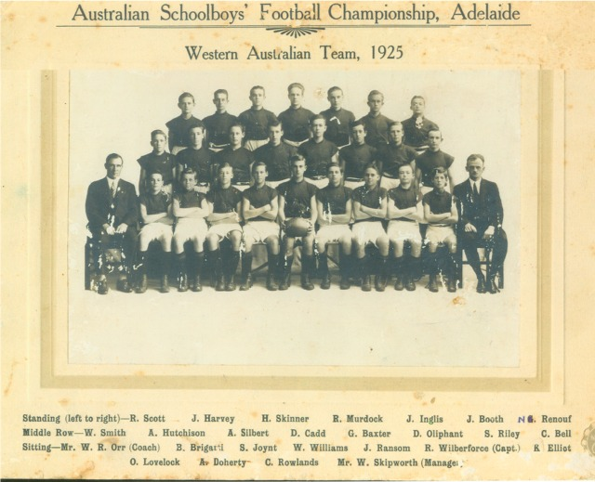

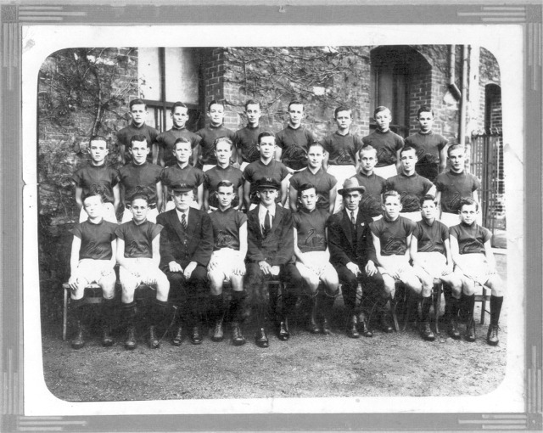

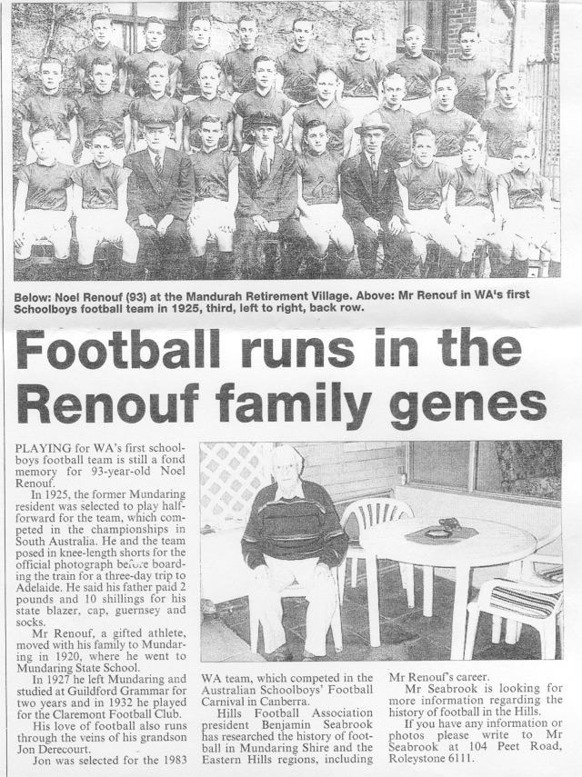
Article from HILLS GAZETTE, July 19 2003
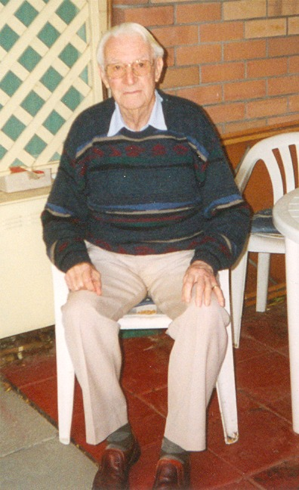
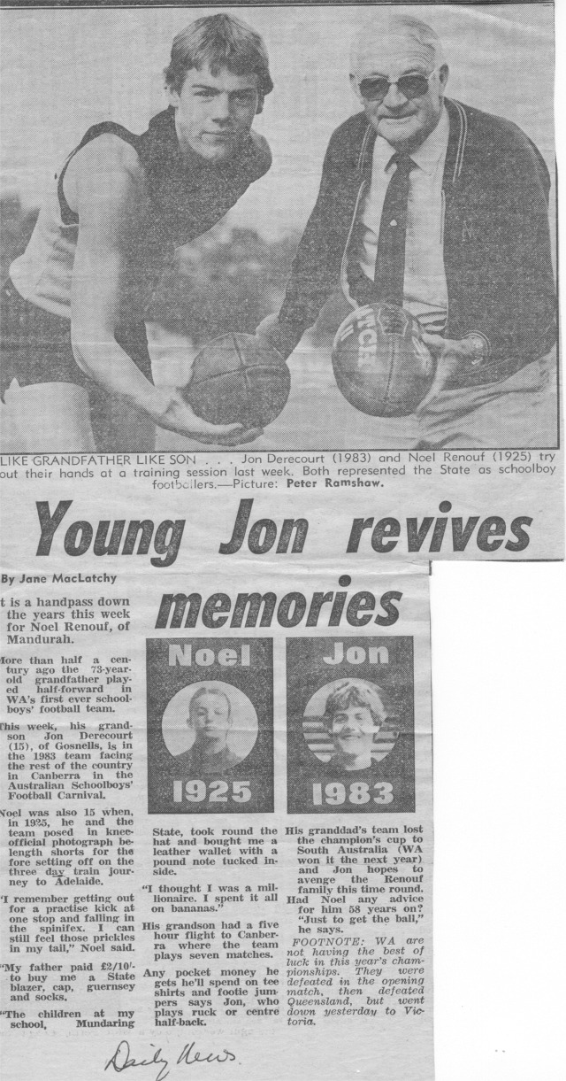
Back to teams

