AFL 15s Boys Results 1938

Competition Dates:
Venue: | Melbourne, VIC
Overall Result:

Officials
Position | Name | School
Coach | C.N Cook | Perth Boys
Manager | W.G Borrman | Fremantle Boys
Gen Sec (WASA) | J Abrahams

Players
Jersey Number | First Name | Surname | School
10 | Neil | Davidson OAM | Junior Tech
4 | Ron | Parker | Fremantle Boys
1 | Arnold (Bud) | Byfield OAM (Capt) | Perth Boys HS
 | Jock | Green **
 | J | Langoulant
 | Ken | Frankish **
 | Keith | Norman
 | J | Leonard
 | R | McIldowie
3 | Frank | Hamilton | Perth Boys HS
 | G | Evans
 | Laurie | O'Reilly **
 | G | Kay
 | Jack | Varley
 | S | Ruck **
 | A | Caporn
 | Robert | McNee (VC)
 | Ron | Hindes
 | R | Foster
 | Vic | Fisher **
 | Ray | Thomas | Fremantle Boys HS
 | Frank | Price **
 | J | Smart
19 | Harry | Townsend | Perth Boys HS
Captain, (VC) Vice Captain, (MW) Medal Winner, * All-Australian

Memories
Playing on the MCG and being undefeated champions. Attending the Grand Final between Carlton and Collingwood. Attendance on that day was 110,000 people. Record Crowd | Ron Parker
Being selected for WA. Playing in a champion team and winning the championship undefeated. Played Metropolitan Juniors and Amateurs football. The late Mr Fred Book, East Perth, invited me to have a run with EP, but the war intervened, and I joined the AIF and saw active duty in N.G. | Neil Davidson
Winning the 1938 Carnival undefeated - beating Victoria on the MCG | Bud Byfield
Beating Victoria on the MCG in first match. The pride in winning the Championship and being undefeated. Meeting many relations in Melbourne | Harry Townsend
'38 travel by train to Melbourne. Throwing boomerangs and kicking football at several stops along line with Aboriginals who came out of desert to see train. Coach Charlie Cook falling off seats at Olympic Park as he urged me on the wing. He forgot the gap between seat rows as he walked along seat tops. Result a very close win to WA in the deciding game against Victoria. Game played in an absolute gale. | Frank Hamilton
Dad recalls the thrill of beating Victoria on the MCG (in storm like conditions), the train trip and the adventure.  Trophy from the WA/Vic game seems to have been awarded by a spectator/official, reads – Interstate Schoolboys Football Carnival, 1938, Presented by, Len Brown, For, Best player in match, WA v Victoria, Won by, R Hindes | Des Hindes [Son of Ron]

Interesting Stories
The whole trip was an adventure for fourteen year old boys | Ron Parker
The late Jack Dyer when addressing the team at the Carlton FC prior to the match, made the following comment to our players, I quote "It does not matter if you don't get a kick all day, providing the player you are playing on does not get one either" unquote. | Neil Davidson
Dad always said what a good footballer he was, the older we get the better we get of course, and being John Todd's uncle he actually taught John how to do the dropkick. Dad was captain of the district team, Warren, before the 1938 carnival, that helped get him selected for the state team I guess. | Des Hindes [Son of Ron]

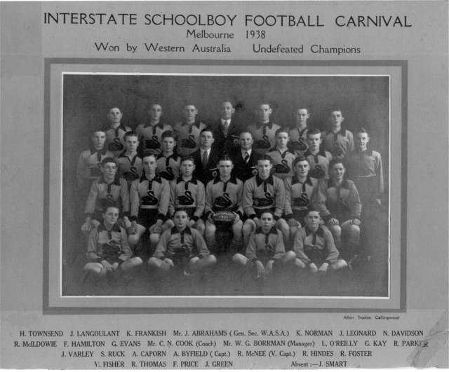

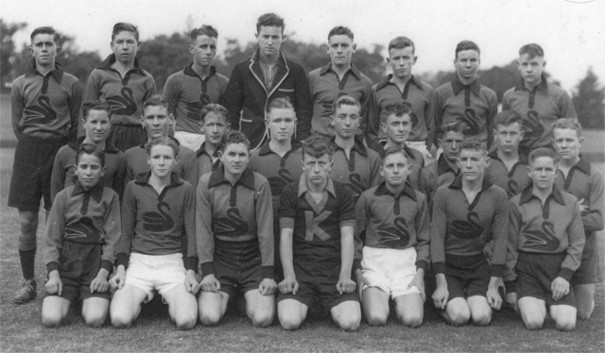

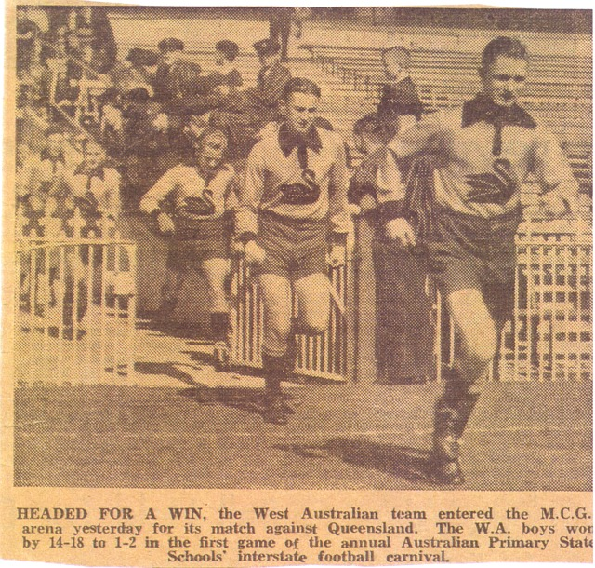

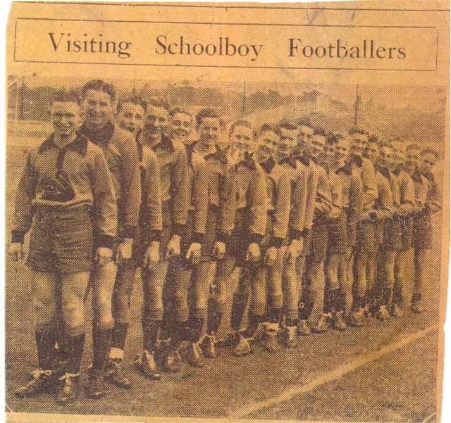

Back to teams

