AFL 15s Boys Results 1939

Competition Dates:
Venue: | Hobart, TAS
Overall Result:

Officials
Position | Name
Coach | W (Bill) English
Manager | J Beckett
WASSA | W Borrman

Players
Jersey Number | First Name | Surname | School
10 | Basil | Robinson | Junior Technical HS
14 | John | Stuart | Perth Boys HS
5 | Ralph | Latham | Midland Junction HS
23 | F | Chalkley | Junior Technical HS
19 | Thomas | Blood | Meckering HS
8 | Roy | Gaunt | Claremont HS
16 | Neil | Riger | Perth Boys HS
7 | K | Faulds | Fremantle Boys HS
2 | G | Evans | Merredin HS
11 | William | Bennett | Perth Boys HS
6 | Vic | Fisher | Perth Boys HS
9 | Colin | McIntyre | Claremont Central
17 | Nick | Grasso | Perth Boys HS
22 | CG | Monkman | Deanmill
15 | Ron | Frankish | Perth Boys HS
18 | A | Sampson | Katanning HS
3 | William | Bathurst (VC) | Fremantle Boys HS
1 | Dixon | Keast **(Capt) | Perth Boys HS
24 | Frank | Gardiner | Perth Boys HS
12 | Don | Stone | Junior Technical HS
20 | W | Allen | Kirup
25 | J | Campbell | Perth Boys HS
4 | A | Anning | Junior Technical HS
21 | R | Tresize ** | Jardee

(C) Captain, (VC) Vice Captain, (MW) Medal Winner, * All-Australian

Fondest Memories
Playing for our state, good team spirit, unfortunately we lost to Victoria by 5 points, after winning all other games | Ralph Latham

Interesting Stories
They travelled to Tasmania by train and boat and they were away 5 weeks, leaving Tasmania on the day war was declared. Basil played as a Half Forward and wore the Number 10. They were defeated by Victoria by 1 goal. He said that the siren went with five minutes to go when the Victorians got in front. | Janice Garwell(neice)
Bill English the coach was unhappy with the bigger lads who would carry little (Todge) John Campbell on their shoulders. He would say he is a player not a mascot. | Ralph Latham

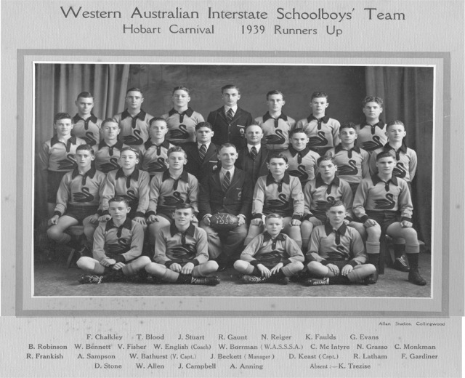
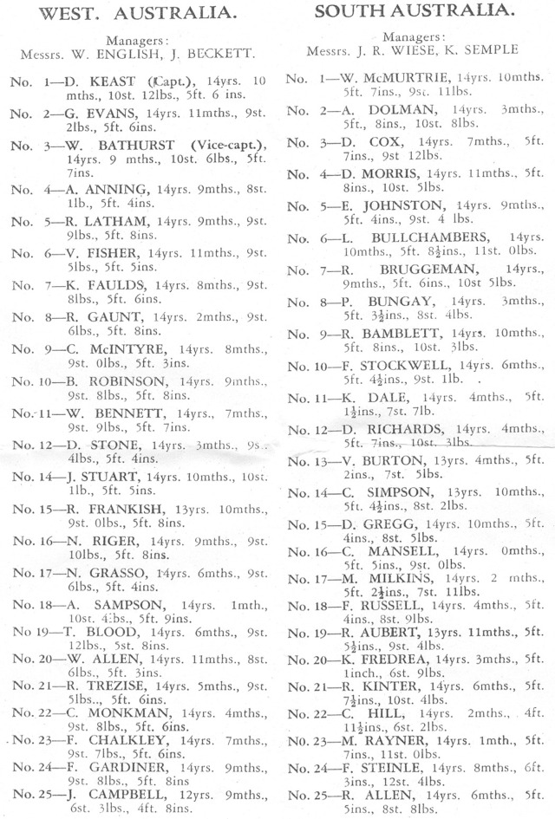
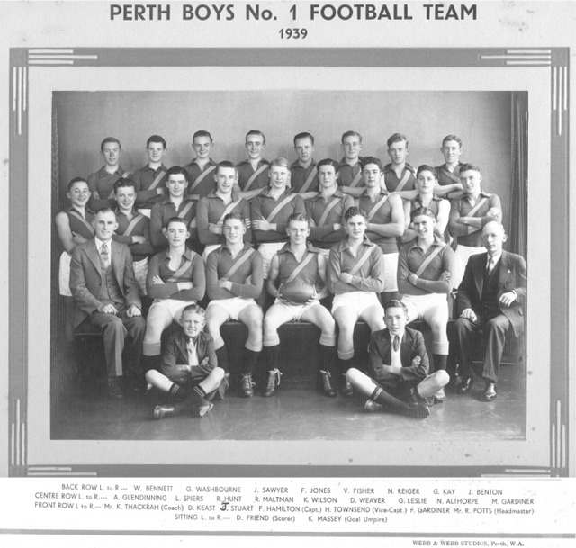

Back to teams

