AFL 15s Boys Results 1948

Competition Dates:
Venue: | Brisbane, OLD
Overall Result:

Officials
Position | Name
Coach | E.G Smith**
Manager | W.K O’Dwyer**
President | C Glew
Secretary | Ken Miller**

Players
Jersey Number | First Name | Surname | School
3 | Ken | Holt | Fremantle Boys HS
25 | Kenneth | Wake (C) | Fremantle Boys HS
12 | Robert | Jones | Perth Boys HS
14 | Greg | Nolan | Forrest High School
8 | Jim | Guthrie | Fremantle Boys HS
17 | Denham | Durack | Quairading State
 | Bob | Sellenger **
 | Neil | Lovelock **
 | Terry | Dyson **
 | Brian | Forrest
20 | Hugh | Ash | Collie HS
18 | Peter | Wallis | Collie HS
 | Dudley | Curtis **
8 | Bert | Softley | Kalgoorlie Central
10 | Lancelot | Bell | Midland SHS
 | Ken | Smith | Perth Boys HS
 | Brian | Leavy
18 | Ernie | Swallow | Collie HS
15 | Alan | Christian | Fremantle Boys HS
9 | Frank | Thomas | Burracoppin
 | Doug | Nelson (VC) **
 | Gordon | Hill
 | Ron | Snell | Kent St SHS
 | Brian | Kennedy

(C) Captain, (VC) Vice Captain, (MW) Medal Winner, * All-Australian

Fondest Memories
Winning the 1948 Carnival and becoming State Champions. Travelling over the Nullabor by train to Adelaide. Collie town raised the $50 for the trip and local tailor Gordon Worth made my trousers. Our first pair of long grey trousers. Honoured at school assembly. | Ernie Swallow
Thrill of going east for the first time. Comradeship. Winning the carnival (undefeated). The service given by the coach and manager | Ken Holt
Beating Vic first up at the Graceville Oval (Don Tallon's home ground) 15-17 to 7-8? | Frank Thomas
The trip to Brisbane and back. Train to Sydney then my first ride in an aeroplane to Brisbane. Then 5 days coming home by train | Denham Durack
Success in winning the Carnival. Ongoing comradeship and several reunions | Robert Jones
Winning the carnival and the Hudson Gold Cup | Hugh Ash
Team friendship even to this day. Some reunions and bring back to WA the Hudson Cup. This donated by Dr Hudson from TAS to be kept after 3 consecutive wins - 1939, 1947 ,1948 by that state (WA). (List of winners is not correct as WA won in 1939 not VIC) | Lancelot Bell
Having my first plane flight from Sydney to Brisbane (DC3 plane). Playing a football game on the Brisbane Exhibition Ground with a track around the perimeter. Being billeted in Indooroopilly, Brisbane together with team mate Lance Bell. Team mate Hugh Ash having a heavy cold when we arrived at Kalgoorlie by train on our journey back home. | Greg Nolan
Great lifelong memories. Also meeting team members, we have every so often a reunion to catch up on our team mates | Alan Christian
The thrill of making the side and the wonderful feeling of pride and pleasure after playing in 6 quarters in a row at Subiaco Oval. The excitement of travelling across Australia by train and 1st flight in a plane from Sydney/Brisbane. Having fun with my new schoolboy friends and we are still friends to this very day. Arranging the first of many reunions of the 1948 side in mid 1970 when 21 of the 25 attended. We also had a 50 year reunion in 1998. Being undefeated in the 1948 Carnival which meant WA kept the Hudson Cup after winning 3 carnivals in succession. 1939, 1947 & 1948. | Ken Smith
Winning the Championship, bringing home the gold cup. Interstate travel, companionship, team gel, reunions (still great friends) | Peter Wallis

Interesting Stories
Having our water pistols confiscated on the south bound Brisbane-Sydney express. | Frank Thomas
The train trip to Sydney - 5 trains - 8 days? Sydney to Brisbane by Qantas Super Consolation. First Australian Rules team to fly. In Melbourne we were billeted out to VIC players. My billets name was Howell from Fitzroy. | Lancelot Bell
To my knowledge the 1948 state schoolboys side has held seven reunions since 1979. Nov 1979, Nov 1980, Nov 1981, Nov 1982, Nov 1986, Sep 1998 | Greg Nolan
Our AFL teams blame the plane trips when they loose. (It's all in the mind) Did not worry us, we sat up all the way to Brisbane in old trains. When Carnival started our talented teams threw everything at the other states. We were ruthless, a bit of the old "G and D". Travel did not worry us! Undefeated was the result

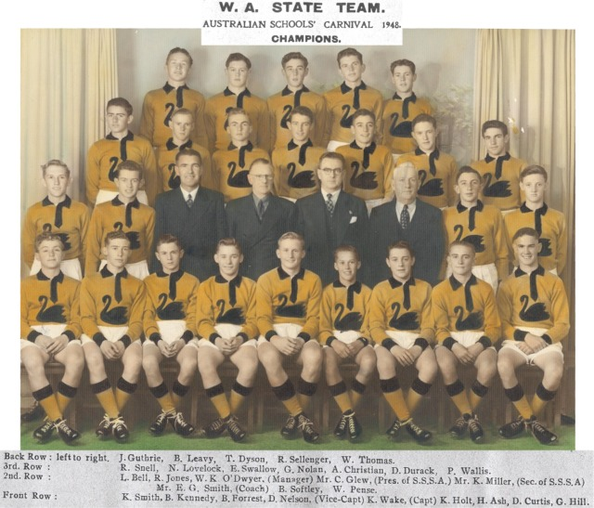

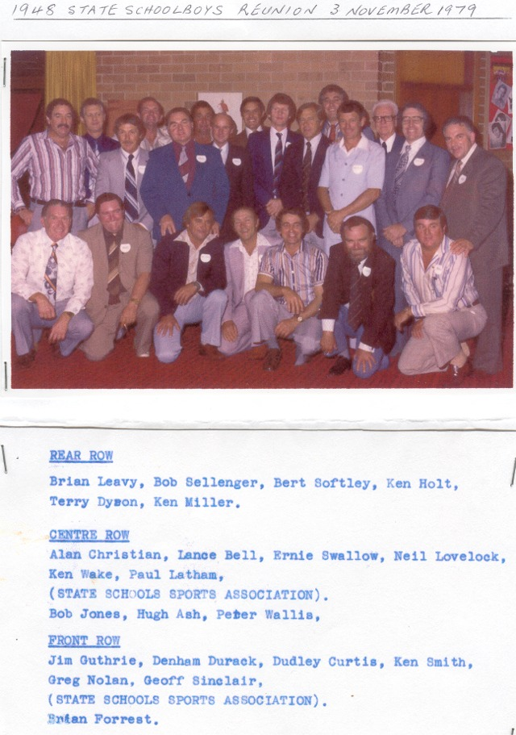

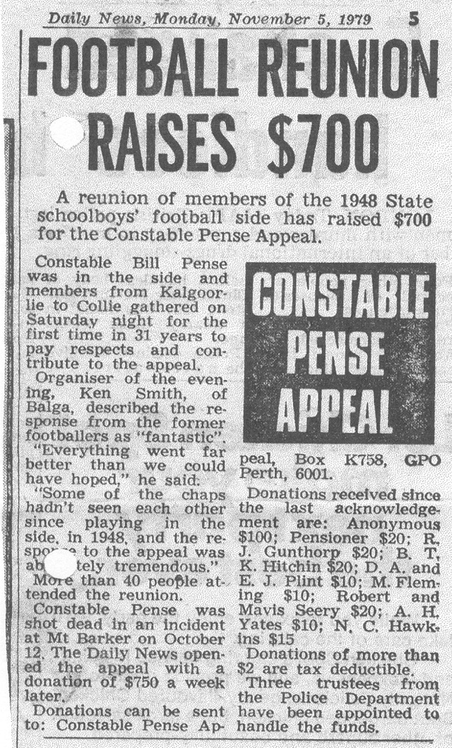

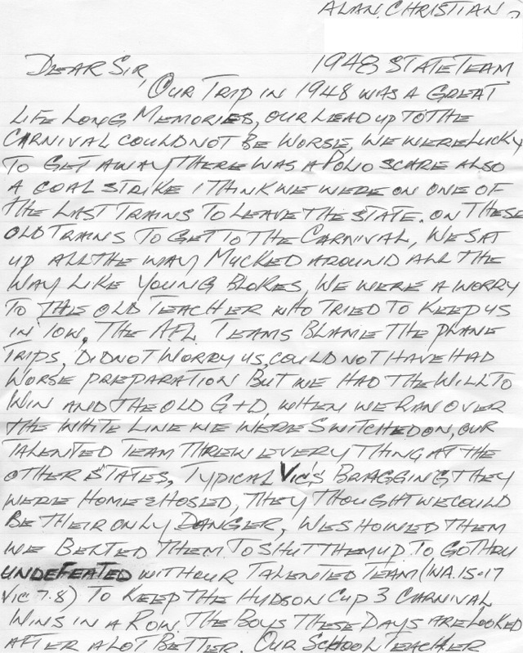
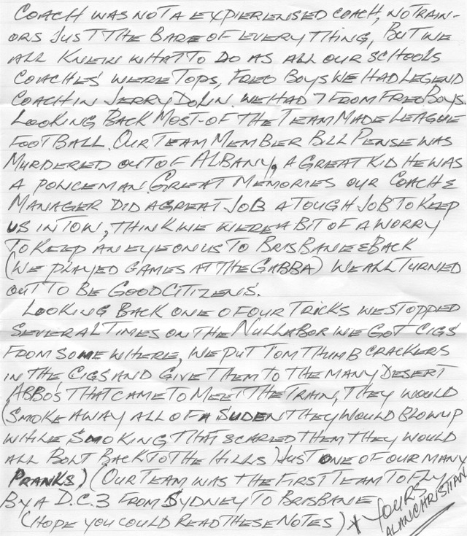
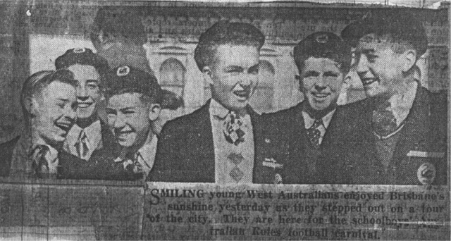
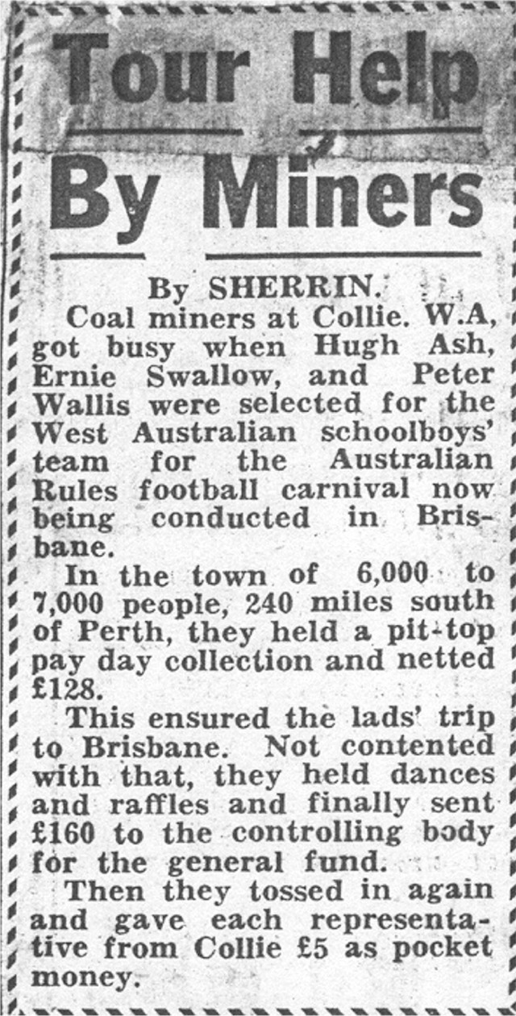
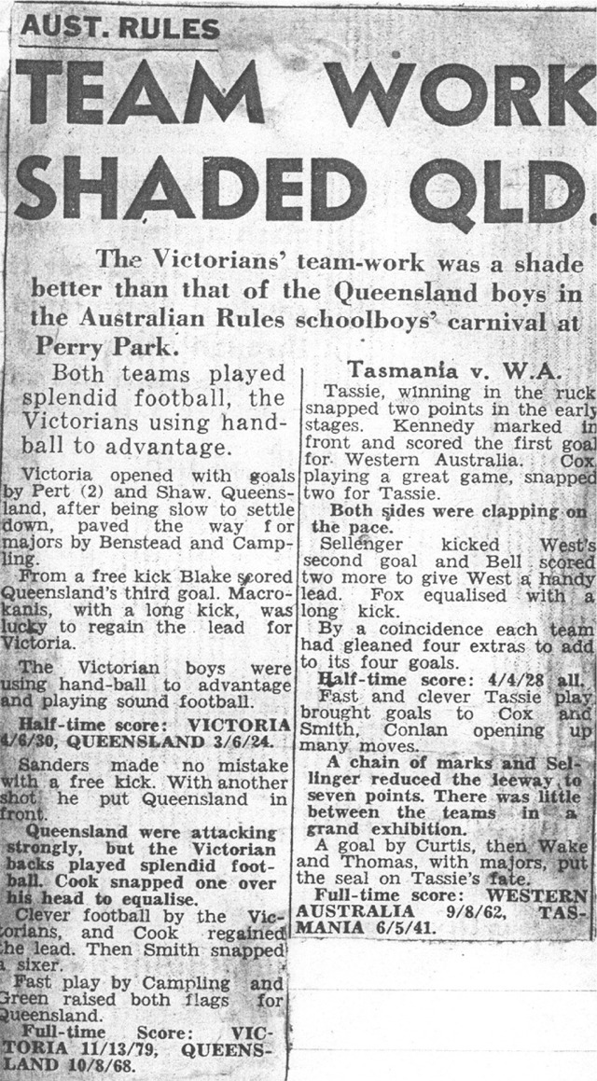
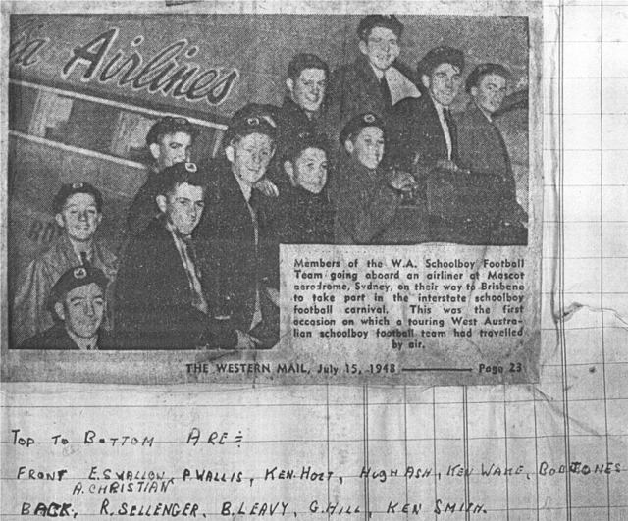
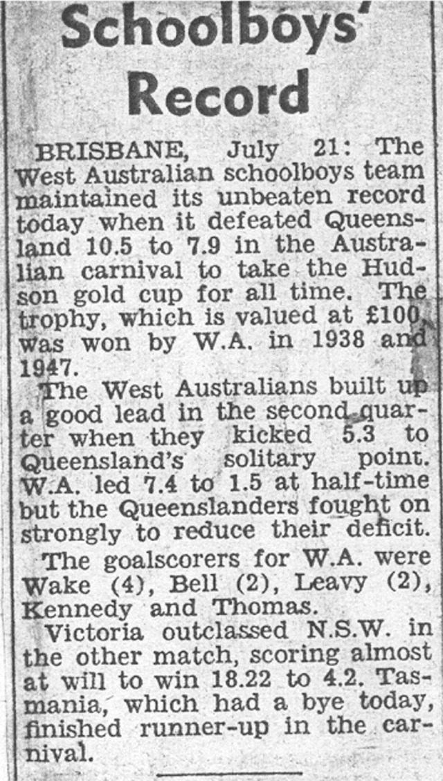
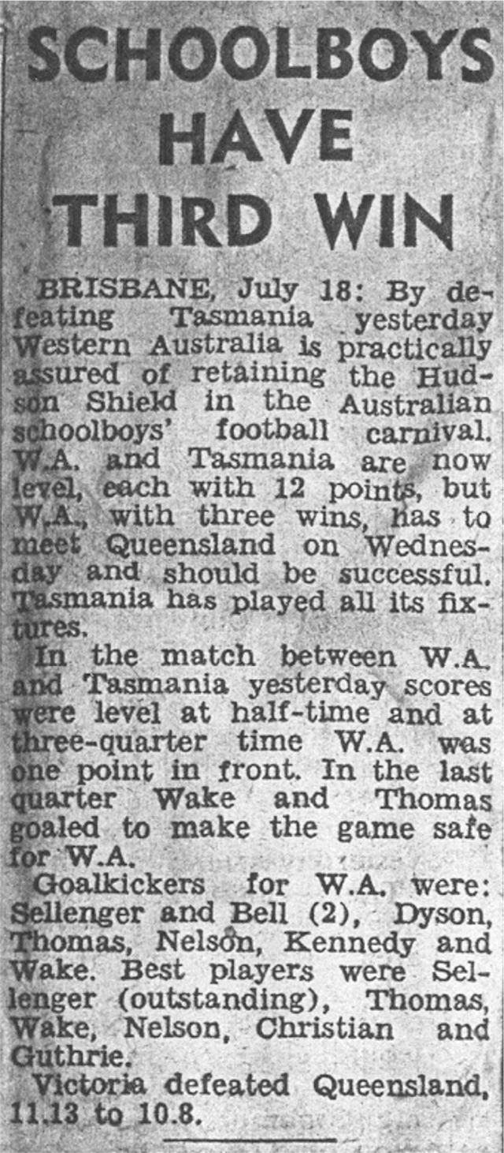
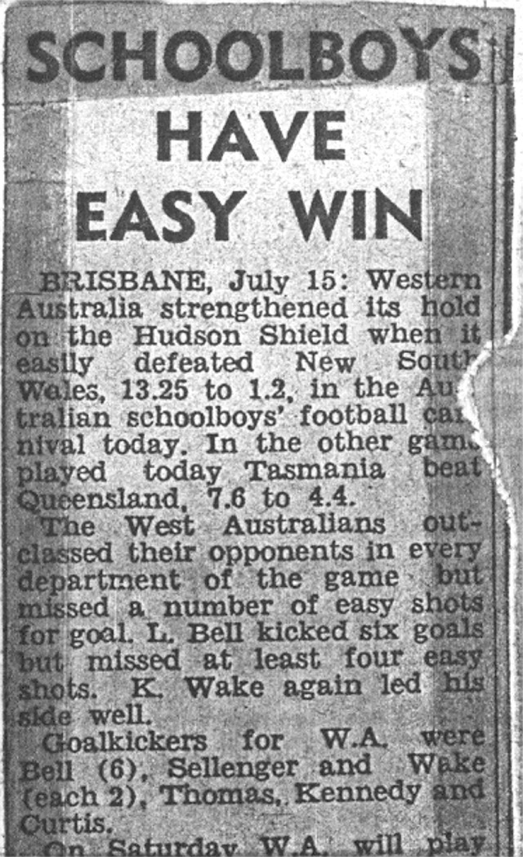
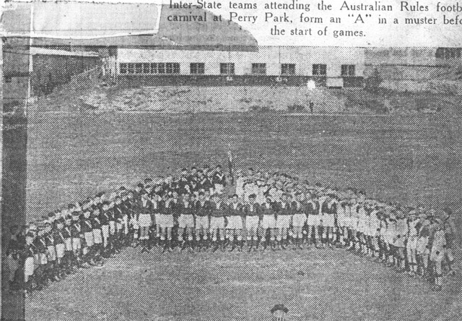
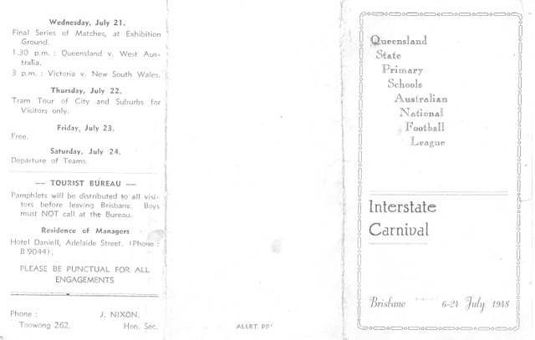
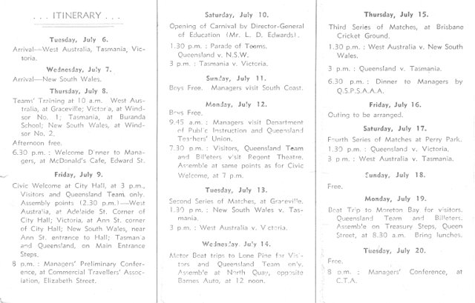
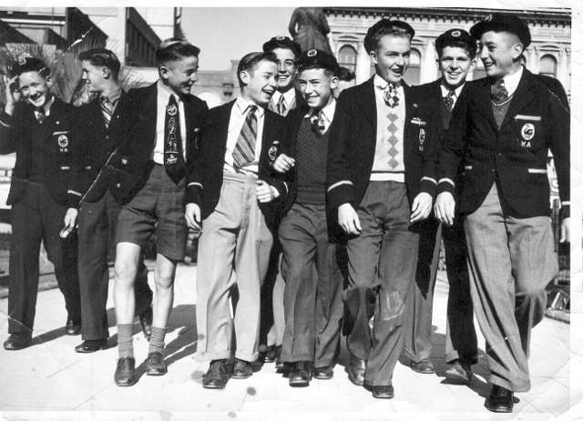
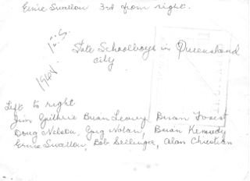
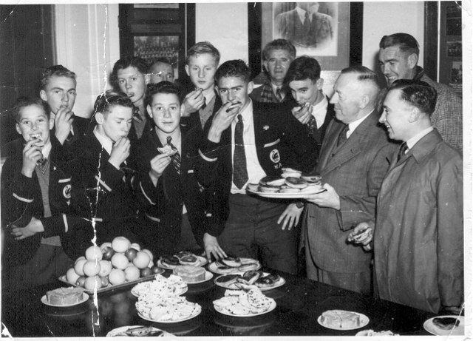
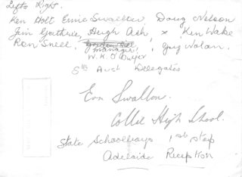

Back to teams

