AFL 15s Boys Results 1951

Competition Dates:
Venue: | Melbourne, Vic
Overall Result:

Officials
Position | Name
Coach | CJ Calcutt
Manager | Hollingsworth
President | CA Glew
Secretary | KW Miller

Players
Jersey Number | First Name | Surname | School
8 | Ron | Keenan | Fremantle Boys
18 | Dick | Earl | Collie HS
11 | Jamie | Stubbs | Norseman State School
2 | Ray | Brown (VC) | Quairading State School
 | Bill | Towers | Kent St HS
 | John | Todd | Fremantle Boys HS
 | Len | Pavy (Capt) | Perth Boys HS
 | Barry | Shepherd ** | Donnybrook
 | Jim | Dwyer | Bridgetown HS
 | Allan | Anderson ** | Fremantle Boys HS
 | Keith | Gillam
 | Maurie | Jecks
 | Michael | Klasztorny | Boyup Brook
 | Dudley | Catherall **
 | Terry | Mannion
10 | Alf | Zinnicker | Bridgetown State School
12 | Colin | Hebbard | Perth Boys HS
 | Bruce | Douglas
 | Trevor | Winter
 | Jim | Dale
 | Ted | Kennedy
 | Keith | Villa
 | Richard | Rapley | Claremont
 | Ken | Moncrieff | Fremantle Boys HS
 | Les | Mumme | Collie HS

(C) Captain, (VC) Vice Captain, (MW) Medal Winner, * All-Australian

Memories
Being runners up to Victoria at the 1951 carnival in Melbourne. Also the fact that Barry Shepherd won the Fairest and Best at Hobart in 1950 and was runner up in 1951 at the Melbourne carnival | Ray Brown
Lifelong friends that I made. Trevor Winter and myself were billeted with a Mr & Mrs Street who ran a small Post Office in a little village on Mt Wellington. I can clearly remember the daily bus trip down the mountain and the wonderful views. In Melbourne Richmond were our host club and we were fortunate enough to have a lot of contact with Jack Dyer, Roy Wright, Bill Morris and other players. Since then I have been a staunch Richmond supporter. | Dick Earl
Coming from the country and a very isolated upbringing - attending the selection carnival and hearing my name read out in the team | Jim Dwyer

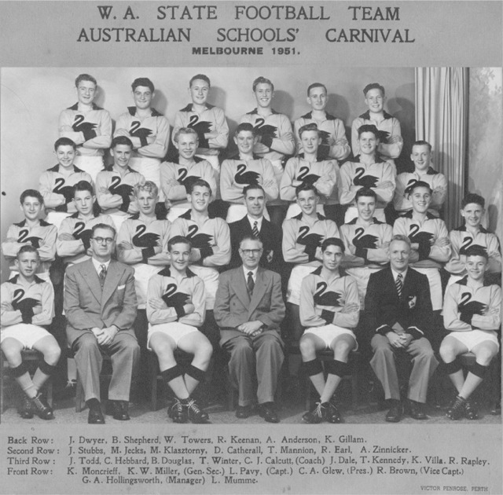

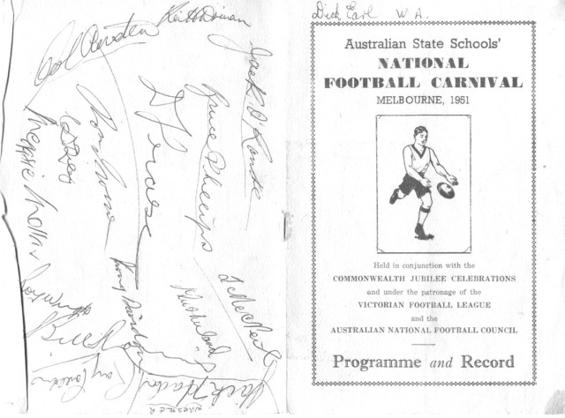
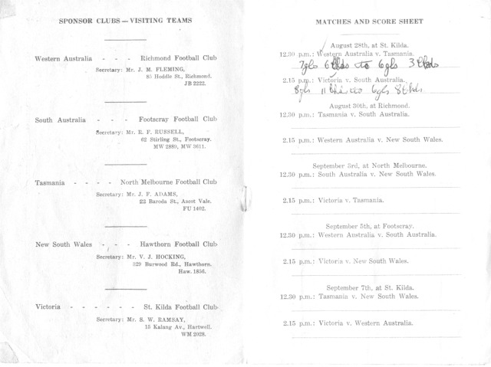
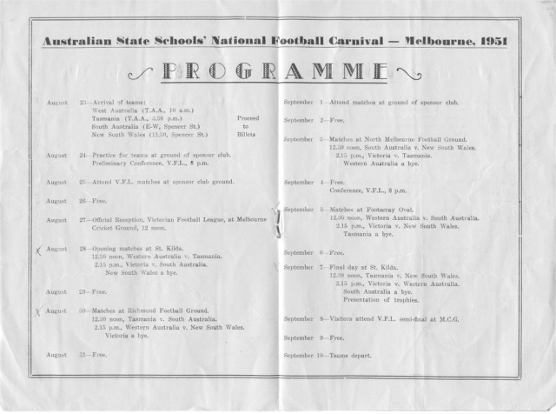
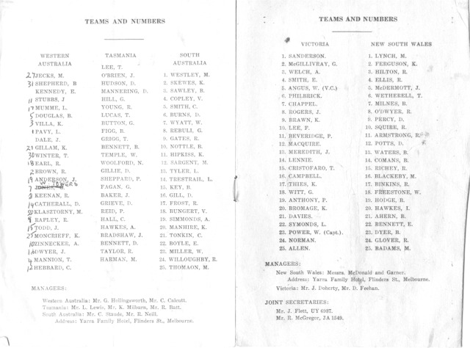
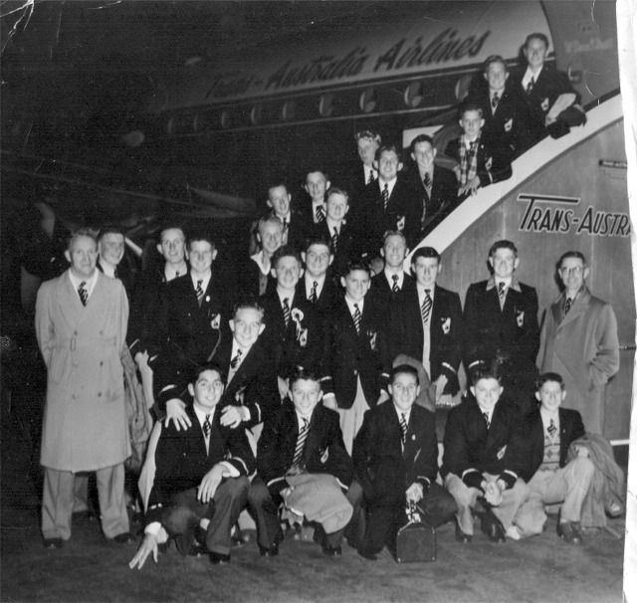

Back to teams

