AFL 15s Boys Results 1952

Competition Dates:
Venue: | Perth, WA
Overall Result:

Officials
Position | Name
Coach | Harold Lewis
Manager | WR Edis
President | N McLeod

Players
Jersey Number | First Name | Surname | School
 | Ray | Prussian
6 | Robert | Ryan | Forrest HS
28 | Jim | Rowberry | Bunbury HS
 | J | Feutrill
 | A | Howson
 | Norm | McDiarmid
 | M | Humphries
24 | Ian | Kessell | Kent St SHS
3 | Jim | Cuzens | Bunbury HS
 | Robert | Ditchburn | Kukerin PS
 | P | Strandly
5 | Brian | Hammersley | Kent St SHS
 | George | Greaves | Kent St SHS
 | K | Gibsone
20 | Richard | Riley | Bunbury HS
 | Les | Thomas
23 | Kevin | McGill | Forrest HS
 | Jim | Scott | Harvey JHS
 | J | McArthur
 | Graham | Yates | Perth Boys HS
 | H | Kuhaupt
14 | Lyle | Ninyett | Midland HS
 | Laurie | Kennedy | Forrest HS
 | John | Todd (Capt)
 | Mike | Klasztorny (VC) | Bunbury HS

(C) Captain, (VC) Vice Captain, (MW) Medal Winner, * All-Australian

Fondest Memories
Coming from a small country town and playing for our state. | Robert Ditchburn
Winning selection. Beating all other states | Kevin McGill
Being able to play football for my state WA. Meeting other players from other states | Ian Kessell
We beat the Vics by 9 pts | Brian Hammersley

Comments
Laurie Kennedy, in one article is quoted as saying that the Victorians were as old as 17 years, I do not think this was true.  He also say's that we hated the Vics with a passion but there was one exception that he probably was not aware of.  I had come with my family from Melbourne to live in Perth just 2 years before. | Rob Ryan
Winning the carnival and not losing a game. | Jim Cuzens
Hobart, Harry Carbon was playing with South Fremantle. We were playing Tasmania. He gave me some encouragement at half time. He had very olive skin with white teeth when there was trouble on the field and Harry was near he always had a big grin on his face. I liked his style - he passed away around the 8th July this month. | Kevin McGill

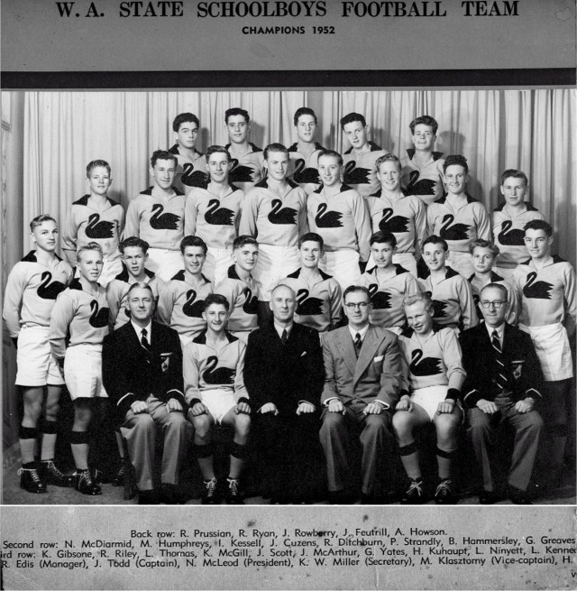

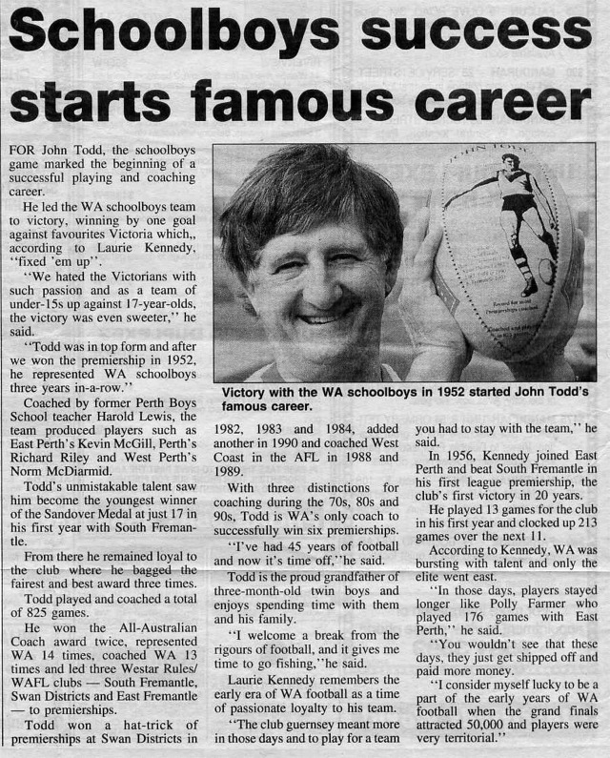

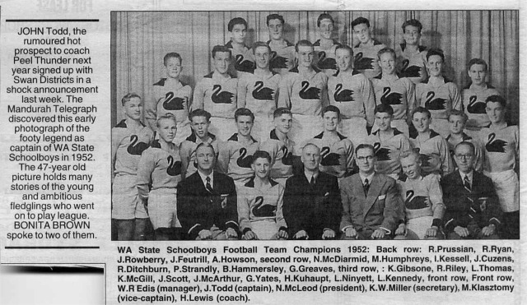

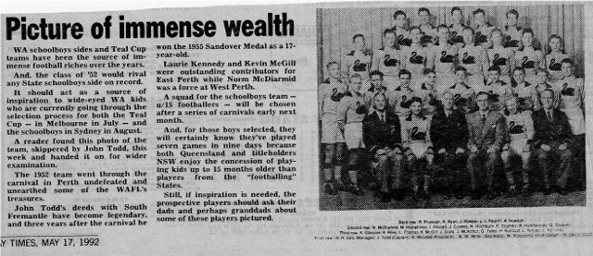

Back to teams

