AFL 15s Boys Results 1956

Competition Dates:
Venue: | Launceston, TAS
Overall Result:

Officials
Position | Name
Coach | G Griffiths
Manager | Sid Mazzucchelli
President | Norm McLeod
Secretary | KW Miller

Players
Jersey Number | First Name | Surname | School
1 | Graham | Taylor (Capt)
2 | Henry | Ugle
3 | Frank | Pyke | Kent St SHS
4 | Colin | Vann
5 | Don | Brown | Quairading HS
6 | Ray | Lucev | Fremantle Boys HS
7 | Owen | Millard | Fremantle Boys HS
8 | Robert | Retallack
9 | Terry | Allen
10 | Lindsay | Jones | Kent St SHS
11 | Frank | Bilcich | Fremantle Boys HS
12 | Merv(spud) | Tames | Kent St SHS
14 | John | Rowan | Fremantle Boys HS
15 | John | Larson | Fremantle Boys HS
16 | Milton | Penny
17 | Peter | Johnston | Fremantle Boys HS
18 | Lindsay | Carslake
19 | Jeffrey | Crabb | Bunbury SHS
20 | Rodney | Cook | Toodyay HS
21 | Darryl | Fowler | Fremantle Boys HS
22 | Ivan | Wunnenburg
23 | Ian | Doncon
24 | Brian | Ham | John Curtin HS
25 | John | Sheppard | Kent St SHS
26 | Ian | Connor
Captain, (VC) Vice Captain, (MW) Medal Winner, * All-Australian

Fondest Memories
Being thrashed by Victoria on a water-logged, muddy York Park. It wasn't our kind of surface but we were terrible. So was I. It was a day to forget, which I haven't yet been able to do. | Frank Pyke
The travel with the other players, the competition itself and in fact the total experience | Lindsay Jones
Having hot milkshakes in Launceston. | Jeffrey Crabb
Played 100 with w.p.f.c. 4 state for w,a. 36 s.m.f.c.in the vfl. Qualified for afl vfl 100 yrs of football dinner and attended this magnificent evening in Melb. 1956 was the year of Melb olympics we passed thru Melb and saw some of the venues like mcg never dreaming that one day I would play on it 3 times.we had a good side in 1956 I was dissappointed I missed the game against Vic. through illness. Being in the best in 2 games prior to that. Lot of players are brilliant at this level but the percentage that go on seems to be small its a shame. | Ray Lucev

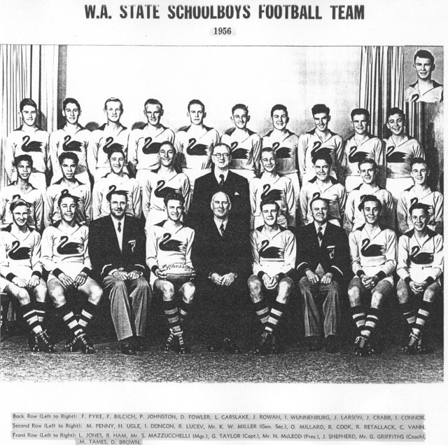
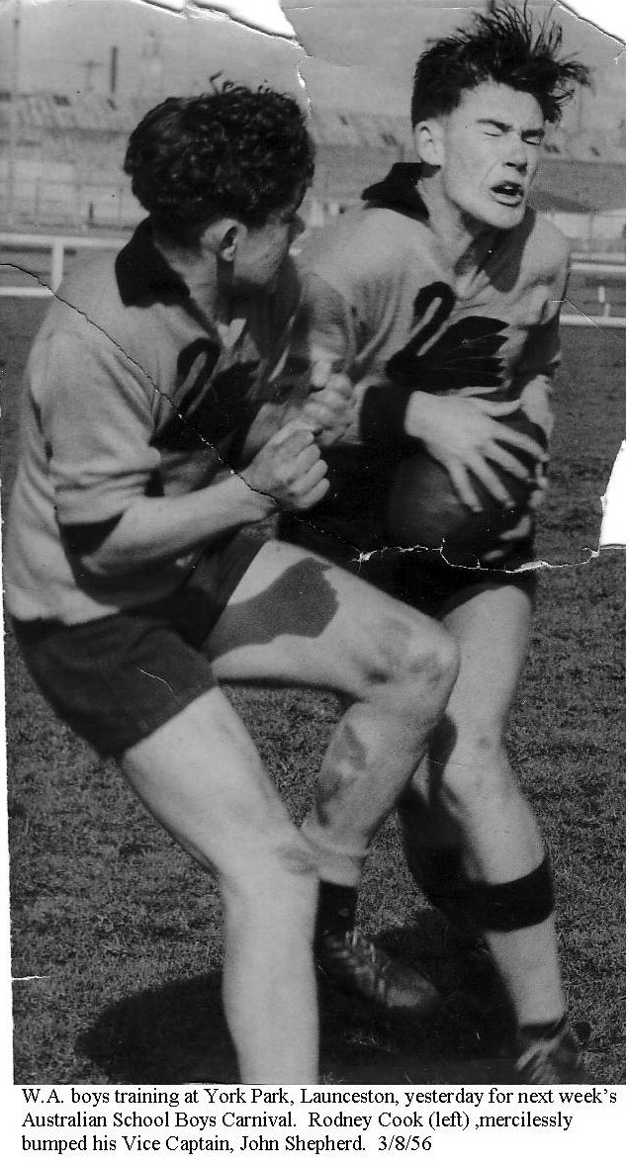
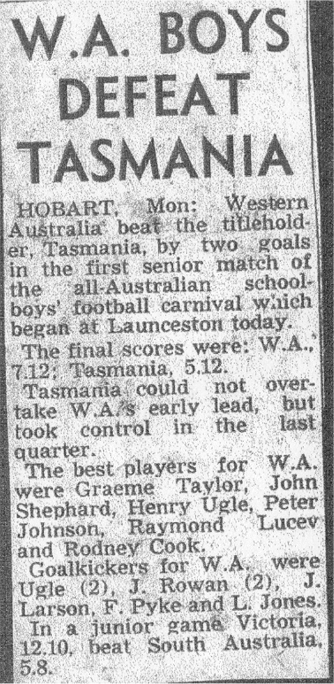
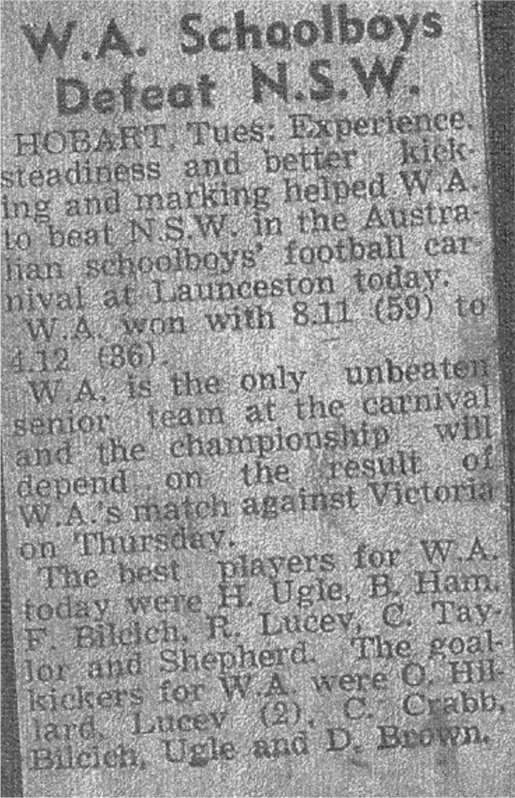
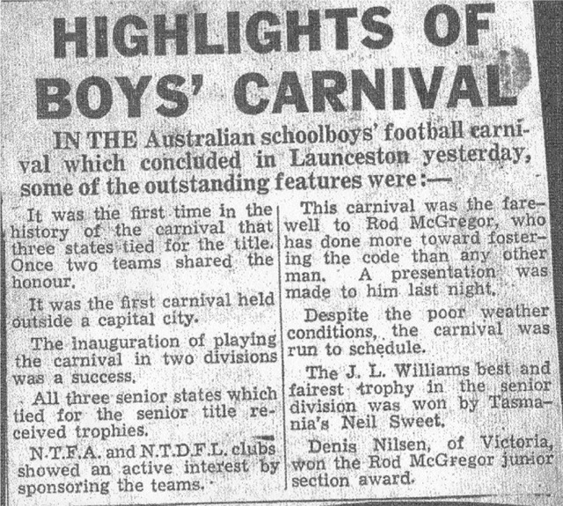
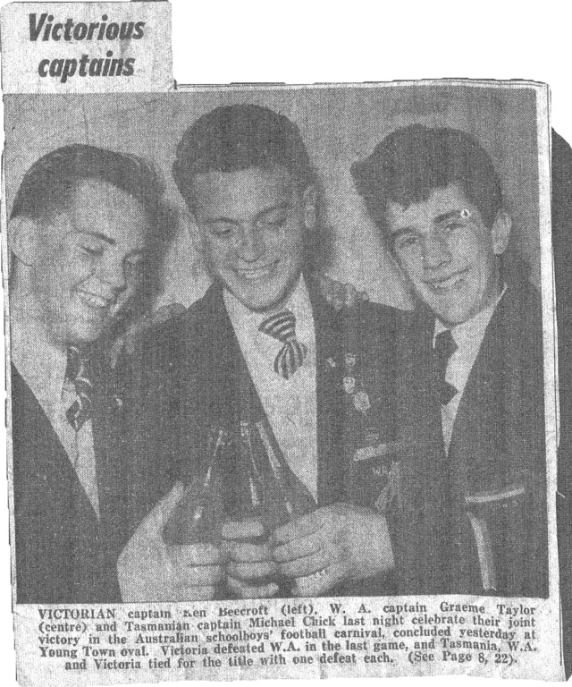
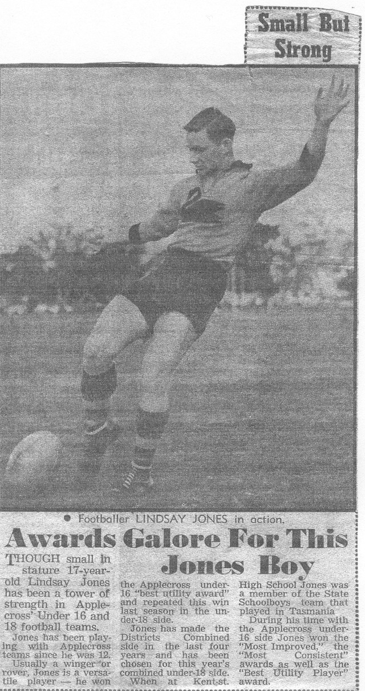
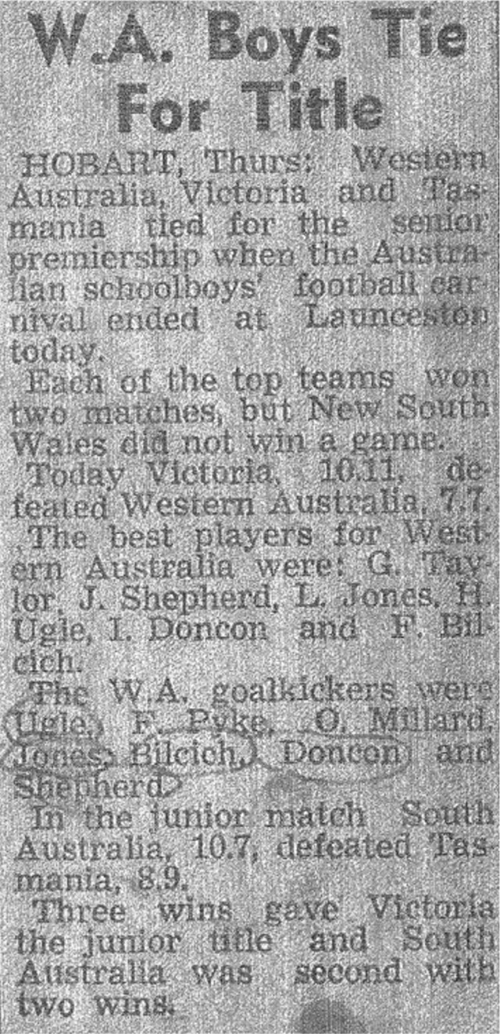
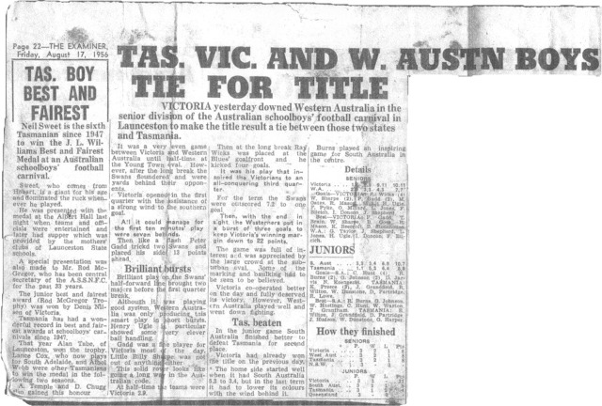

Back to teams

