AFL 15s Boys Results 1958

Competition Dates:
Venue: | Perth, WA
Overall Result:

Officials
Position | Name
Coach | Neville Reynolds
Manager | WK Thackrah
President | Norm McLeod
Secretary | KW Miller

Players
Jersey Number | First Name | Surname | School
3 | Rowland | Sprigg | Tambellup HS
14 | Albert | Stronach | Midland Junction HS
2 | William | Dienaar | John Curtin HS
4 | Robin | McGregor | Albany HS
6 | John | Anderton | Perth Boys HS
8 | Douglas | Francis | Kent St HS
11 | Malcolm | McRae | Mt Lawley HS
12 | Leslie | Pratley | Armadale HS
15 | Thomas | Wedgewood | Kent St HS
5 | Brian | Turkich | Midland Junction HS
20 | Robert | Ward | Hillcrest PS
18 | Robert | Page | Midland Junction HS
19 | Ralph | Johnson | Belmont HS
17 | Georgs | Bialobrodzki | Belmont HS
10 | Michael | McClure | Tuart Hill HS
21 | Gerald | Wills | Perth Boys HS
13 | Colin | Ryan | Kent St HS
9 | Peter | Hogan | Forrest HS
23 | Kevin | Loaring | Applecross HS
24 | John | Maddern | John Curtin HS
1 | Glen | Bennett (Capt) | Perth Modern
7 | Ian | Forward (VC) | Belmont HS
16 | John R | Aylmore | John Curtin HS
25 | Trevor | Slattery | Collie HS
22 | Russell | Higgins | Albany HS
Captain, (VC) Vice Captain, (MW) Medal Winner, * All-Australian

Memories
Turning up at Subiaco Oval for our first game against South Australia not knowing if I was playing. The players came running out to meet me and told me to hurry up as I was playing on the wing. I can still remember my first kick. I took a mark at centre half back, everyone cheered. I layed back into a dropkick and the bloody ball went off the side of my boot. South Australia won, but I didn't play too bad. | John Anderton

Interesting Stories
I am also proud of the fact that my youngest son Jeremy represented the state schoolboys in 1993 at Melbourne. He played every game and got a third and fourth best in two of the games. Jeremy was lucky enough to play in Melbourne and was billeted out to Daniel Harford's home (former Hawthorn) player who was captain of Teal Cup for Victoria the following year. My wife and I went to Melbourne to follow Jeremy and had a ball. When Played in 1958, the carnival was in WA so I missed out on a trip over east. I know what it would have been like. | John Anderton
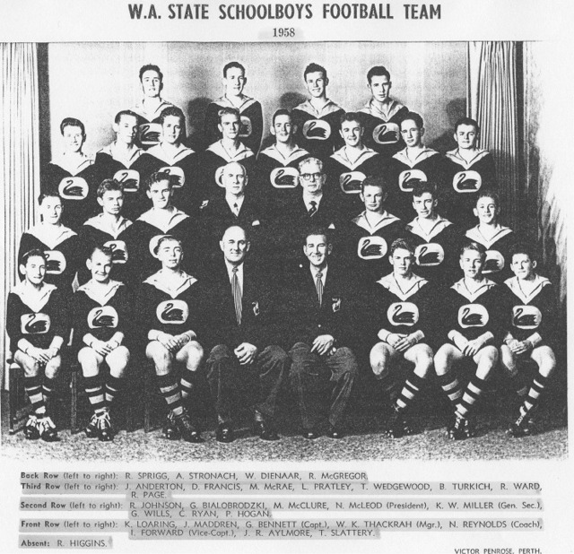

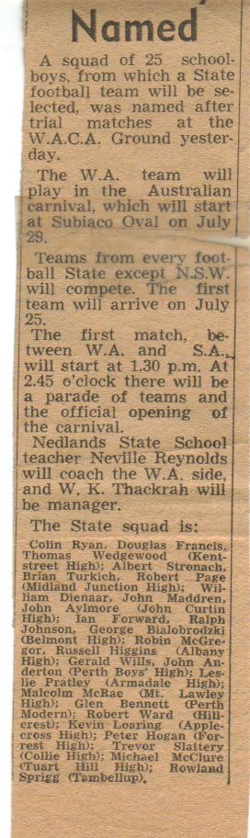

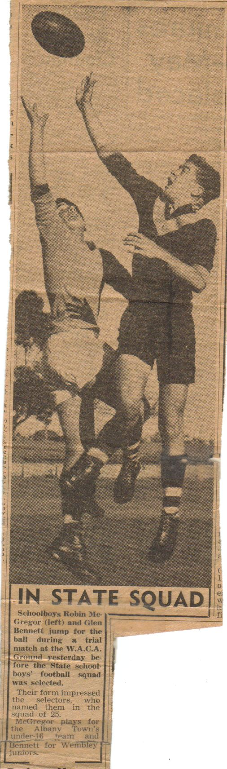
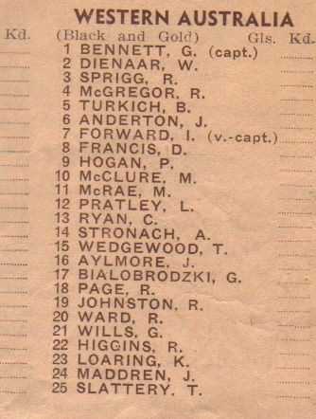
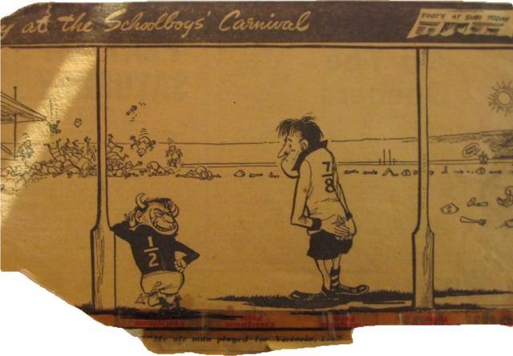
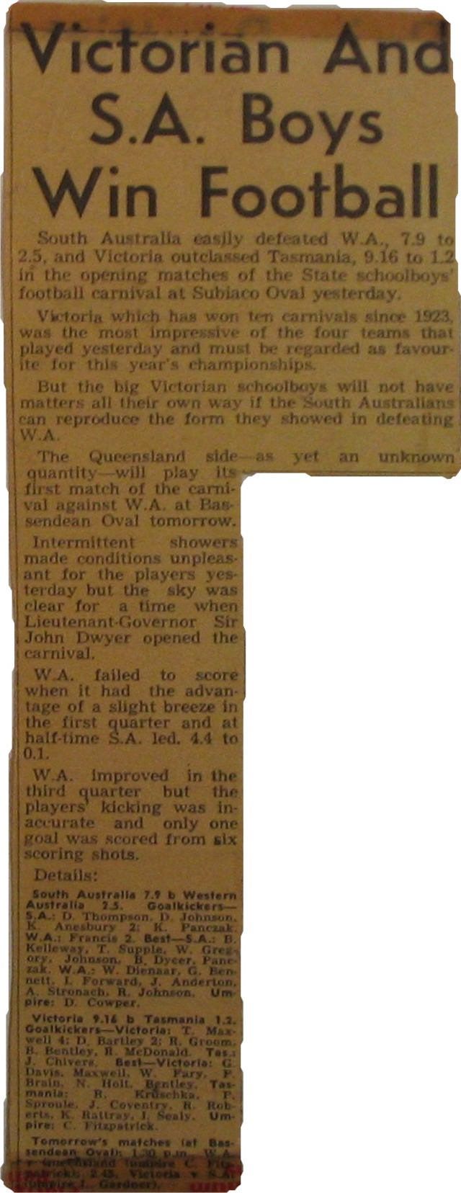
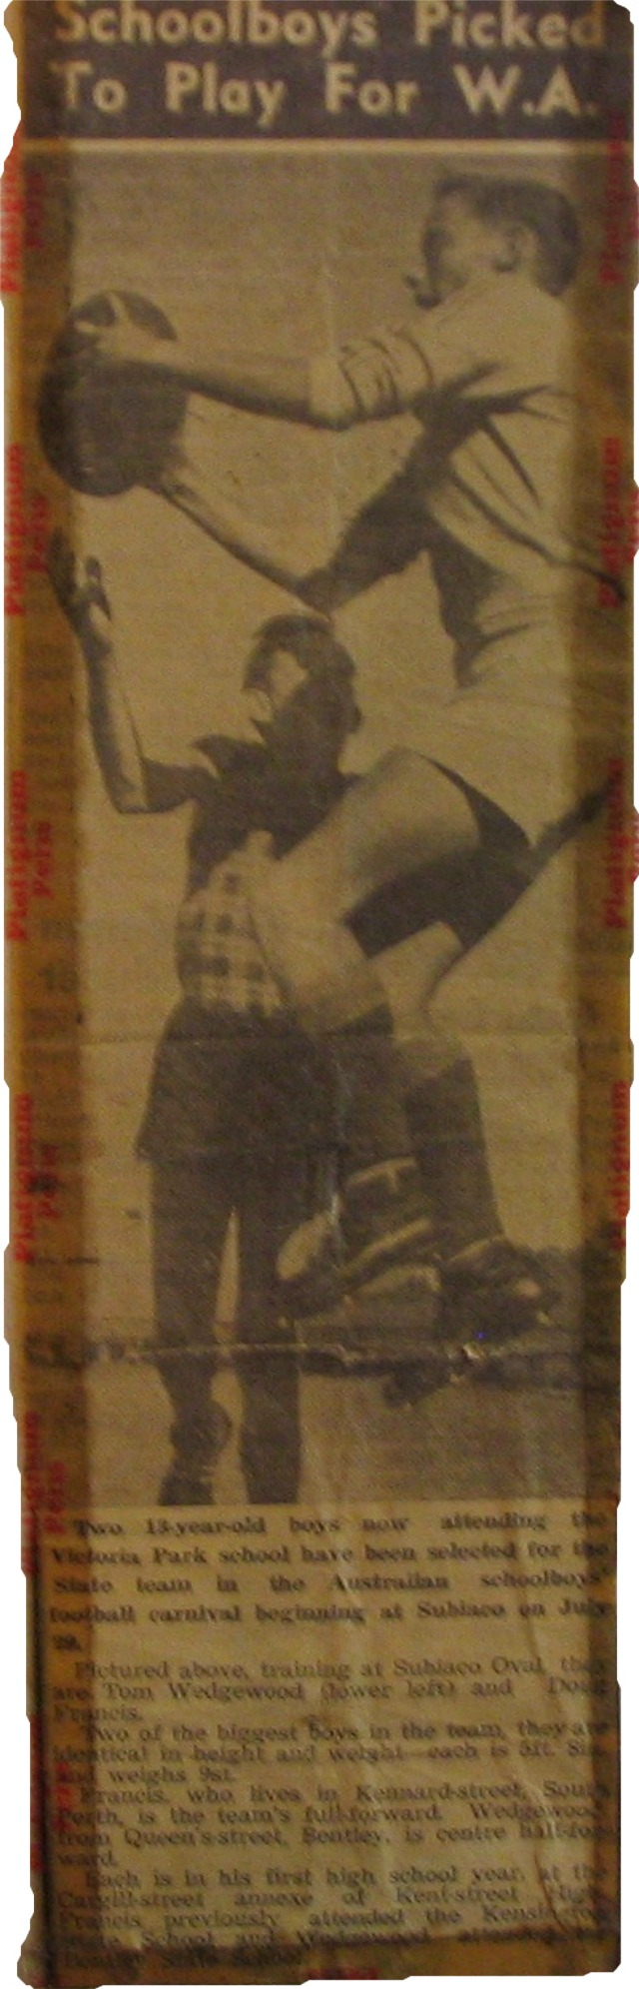
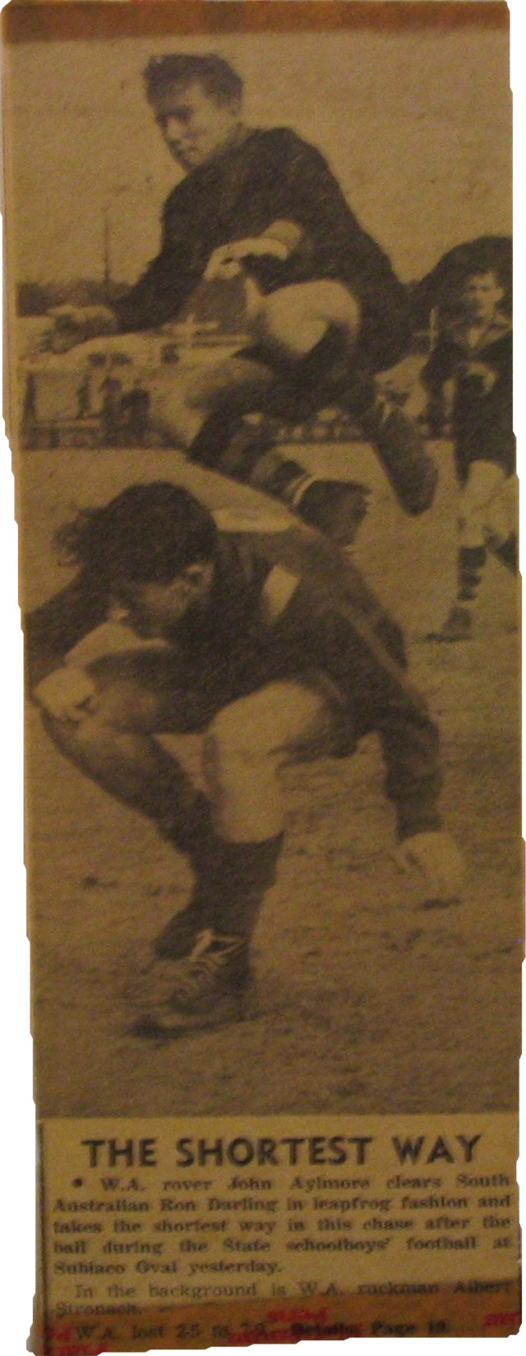
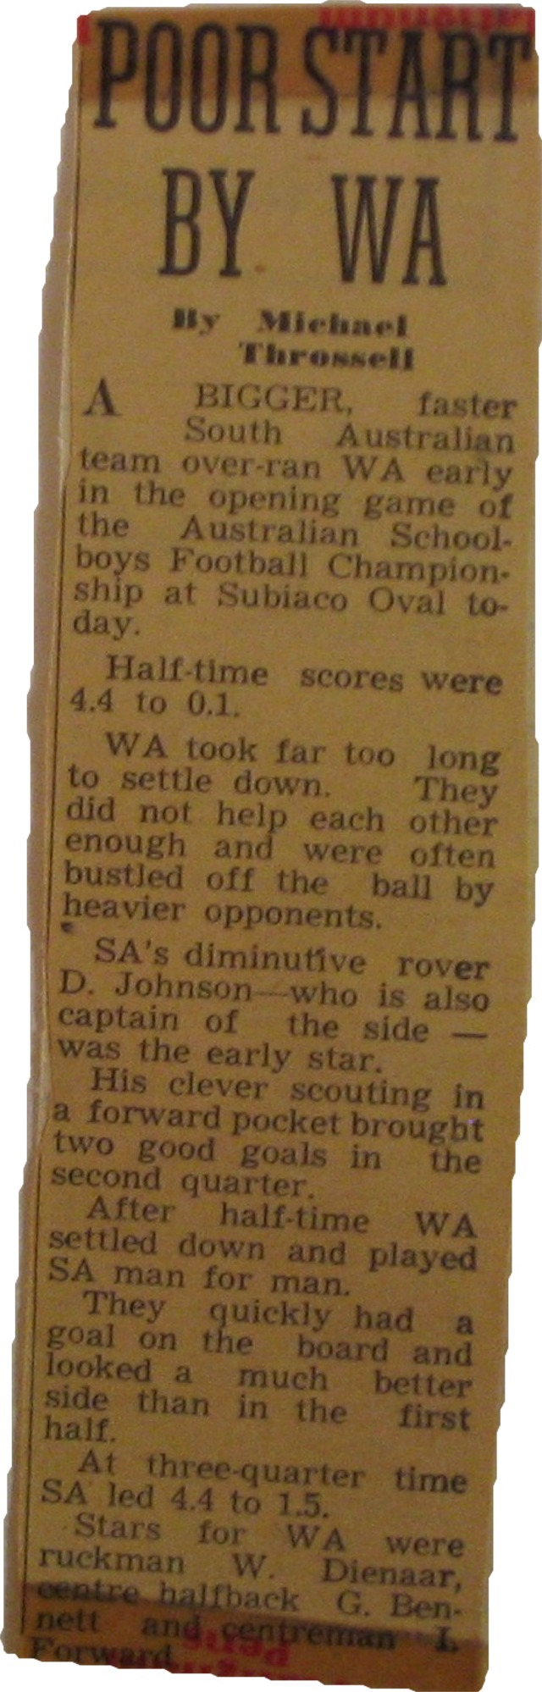
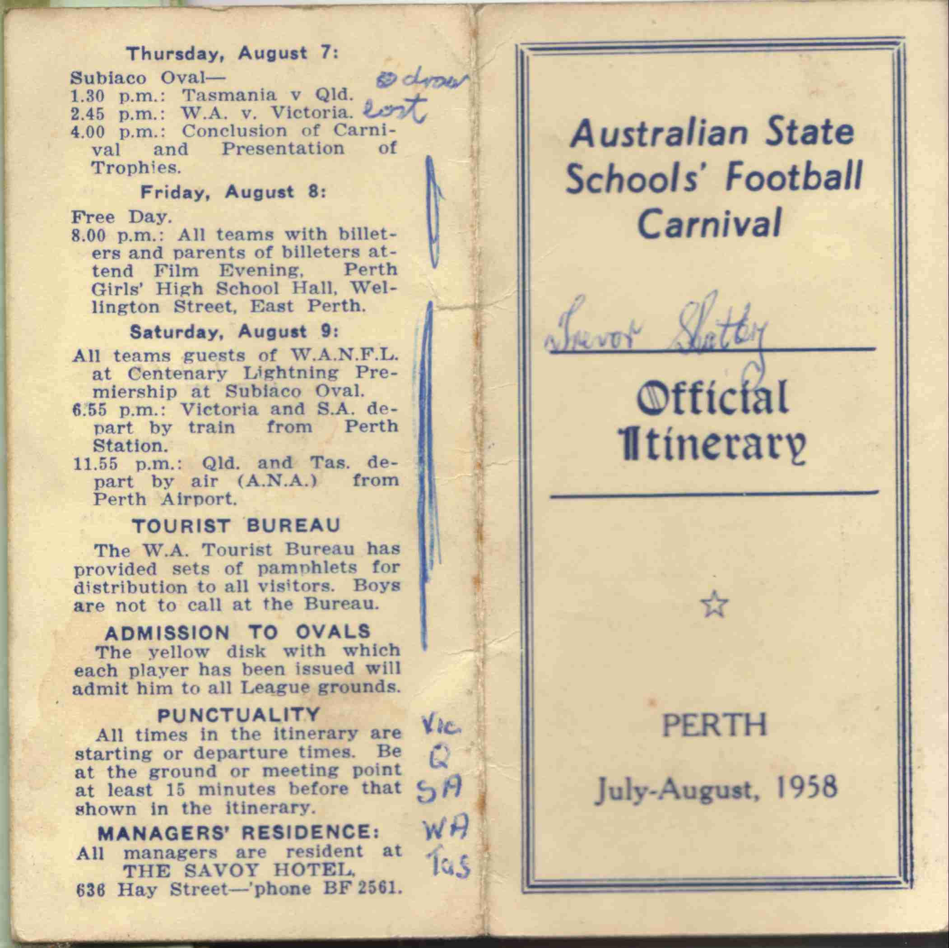

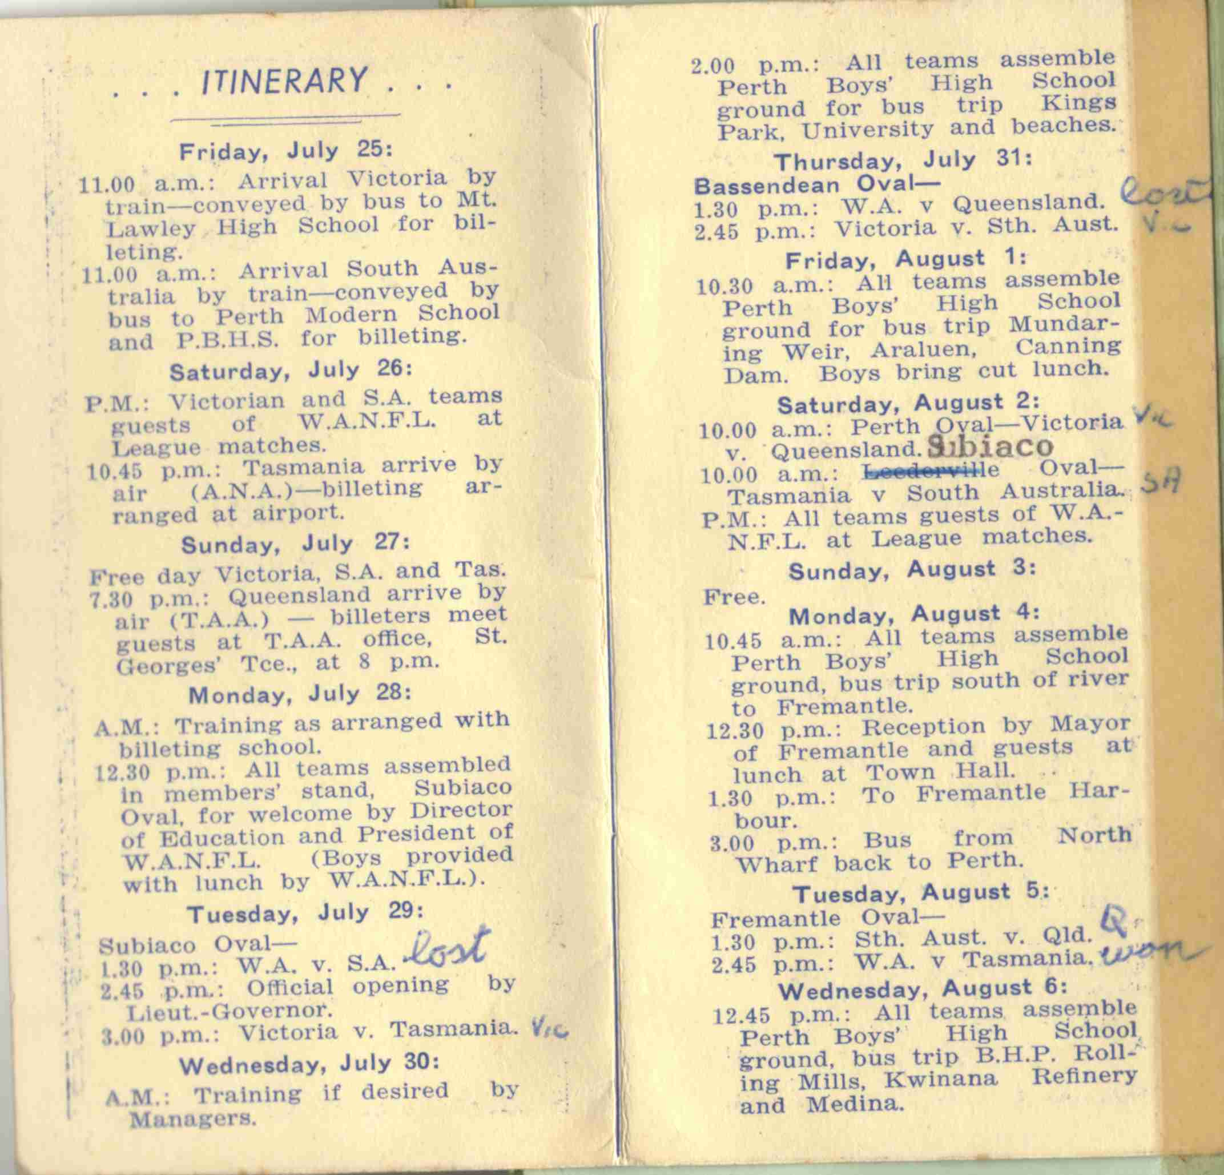

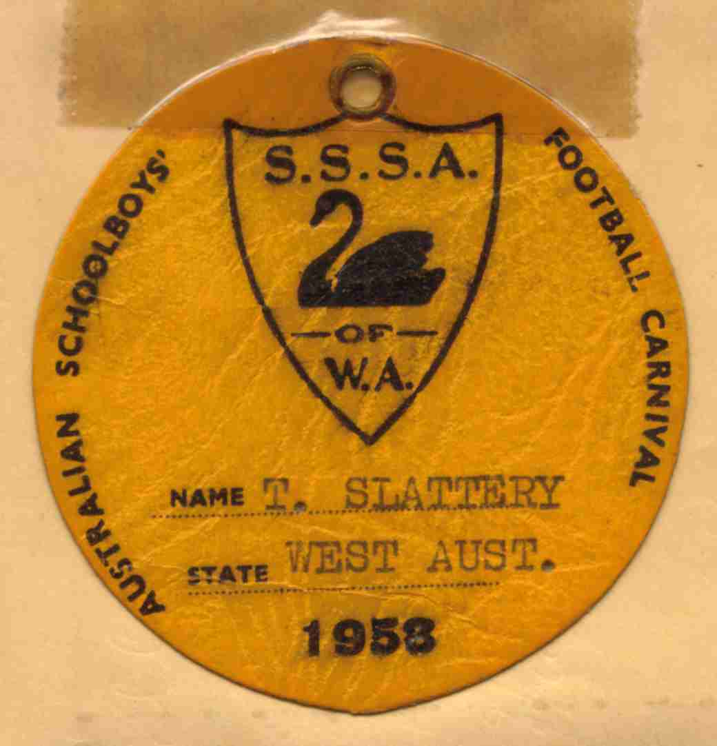

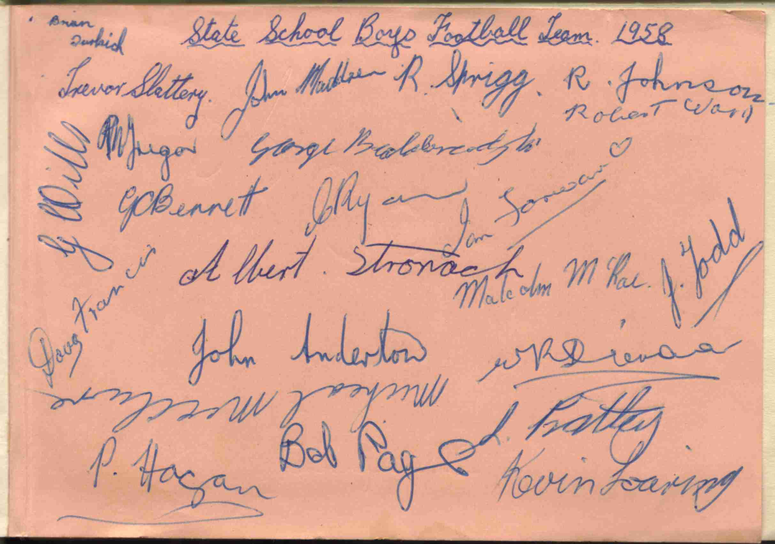

Back to teams

