AFL 15s Boys Results 1960

Competition Dates:
Venue: | Adelaide, SA
Overall Result:

Officials
Position | Name
Coach | Percy Oliver
Manager | Ben Cook
President | N McLeod
Secretary | K Miller

Players
Jersey Number | First Name | Surname | School
 | Robert | Scott
 | David | Thomas
6 | Michael | McCarthy | Perth Modern
17 | Robert | Jardine | Applecross HS
 | John | Wall
 | John | Griffiths
 | Ray | Hill
 | David | Goddard
 | Gary | Saunders
 | Spencer | Williams
 | Fred | Lewis
11 | Trevor | Sprigg | Wagin JHS
 | Graeme | Mabbs
 | Alfred | Howat | Tuart Hill SHS
 | Alan | Drake
 | Alan | Newman | Applecross SHS
 | Greg | Brehaut **
 | Terry | Vaughan
 | Robert | Ward (Capt) | Mt Lawley HS
 | Terry | Opie
 | Ted | Junko
23 | Terry | Pryor | Perth Modern
 | Wayne | Richardson
5 | Frank | Alexander | Hollywood HS
 | Alan | Haynes

(C) Captain, (VC) Vice Captain, (MW) Medal Winner, * All-Australian

Fondest Memories
Beating Vics and winning Championship 1960 | Robert Ward
Undefeated champions - first time for 20 yrs? Camaraderie generated in the train trip across the Nullabor. Lasting friendly rivalries. | Trevor Sprigg
We beat Victoria and won the Championship | Ron McCarthy

Interesting Stories
Later played for WA with Fred Lewis and Greg Brehaut against Wayne Richardson who played for Victoria (1968). Percy Oliver's comment after we narrowly beat Victoria. "I don't usually swear to boys but - you bloody beauty!" | Trevor Sprigg

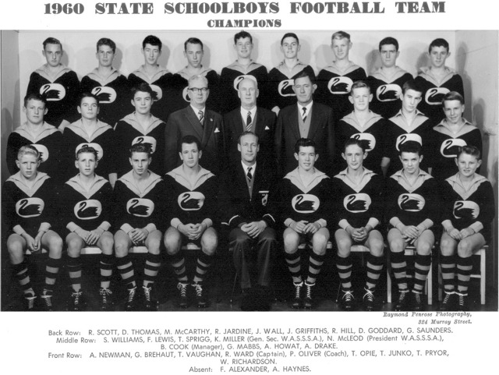

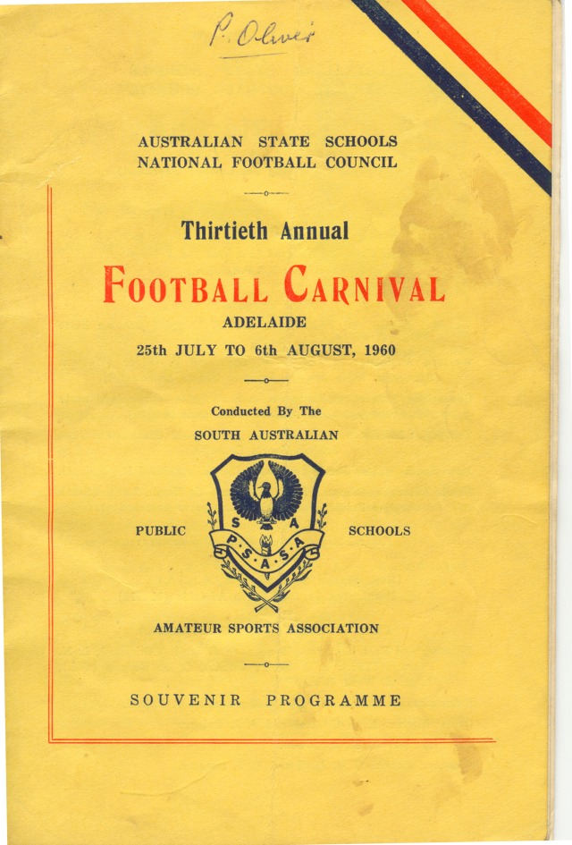

Back to teams

