AFL 15s Boys Results 1962

Competition Dates:
Venue: | Melbourne, VIC
Overall Result:

Officials
Position | Name
Coach | Hal Symons
Manager | Stan Hughes**

Players
Jersey Number | First Name | Surname | School
 | William | Hanrahan | John Curtin?
2 | Jeffrey | Lind | Tuart Hill HS
 | Raymond | Snell
 | Murray | Thomas
 | William | Schofield | John Forrest HS
 | John | Lange | Hamilton Hill HS
7 | Peter | Kynaston | John Curtin HS
 | Ian | Conole
 | Kenneth | Ferguson
 | Rodney | Hancock
 | Maxwell | Oaks | John Forrest HS
12 | Brent | Armanasco | John Forrest SHS
 | Ross | Marshall
 | Darryl | Wade
 | Paul | Hardie
17 | Bruce | Cornish | John Curtin HS
 | Keith | Edwards
 | Gerald | Isegar
 | Roger | Nicholas
 | Terry | Romaro
 | Leonard | Newman | John Curtin HS
 | Peter | Martin | Scarborough HS
24 | Graham | Burnett | Narrogin Agric SHS
 | Thomas | Leggo (Capt) | Northam SHS
 | Terence | Fitzgerald | Melville SHS

(C) Captain, (VC) Vice Captain, (MW) Medal Winner, * All-Australian

Fondest Memories
First opportunity to travel interstate. 1st Semi Final VFL - Carlton v Melbourne | Peter Kynaston
Travel in train to and from Melbourne. Playing on hard Victorian grounds in appropriate footware. Watching Carlton in a game - Sergio Sylvani. Being hosted by Essendon - Hugh Mitchell | Brent Armanasco
For a kid of 13 years of age who had never really been to the city, Melbourne was just an awe inspiring, overwhelming experience. Apart from the thrill of representing WA on the field, the other highlight of the trip was attending a VFL semi final between Carlton and Melbourne at the MCG. The train journey was also an event never forgotten. We were billeted privatley and the couple that I stayed with were very welcoming and homely which in turn made the whole experience much more enjoyable. | Graham Burnett

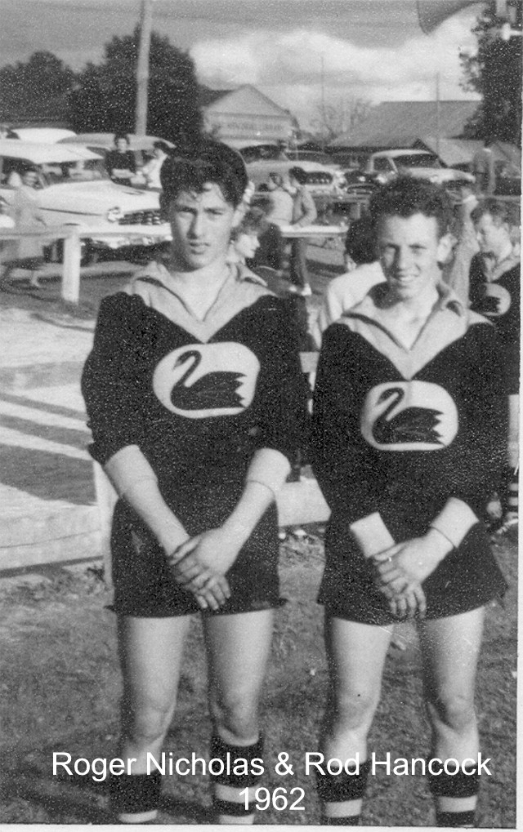

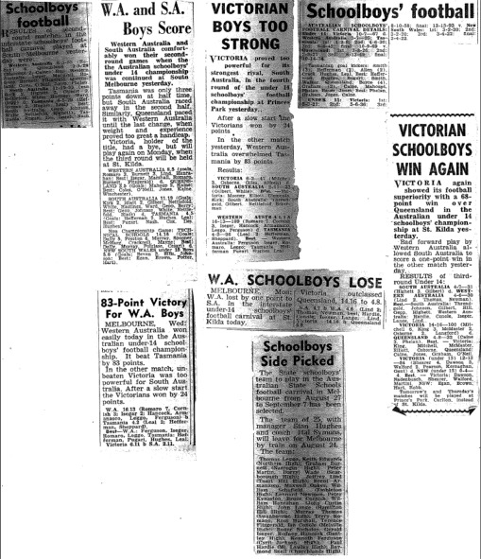

Back to teams

