AFL 15s Boys Results 1963

Competition Dates:
Venue: | Brisbane, OLD
Overall Result:

Officials
Position | Name
Coach | Geoff Sinclair
Manager | Frank Hamilton

Players
Jersey Number | First Name | Surname | School
25 | Stan | Bradshaw | Hollywood HS
 | David | Williamson
 | Zoran | Car
3 | Raymond | McCreery | John Forrest SHS
 | Max | Oakes
 | Chris | Bell
 | Barry | Young
 | Max | Doncon
 | Neil | James
 | Jon | Harvey
 | Michael | Scafidi
 | Graeme | Needs
 | Ian | Penny
 | Ian | Cunningham
 | Kevin | Lindsay
15 | Peter | Metcalf | Melville SHS
 | Ray | Parry
 | Ray | Famlonga
14 | Alan | Dunn | Hamilton SHS
 | Glynn | Williams
 | John | Garnaut
 | Ian | Miller
 | Ken | McAullay
 | John | Ovens
2 | Hans | Verstegen | Armadale SHS

(C) Captain, (VC) Vice Captain, (MW) Medal Winner, * All-Australian

Fondest Memories
Beating the Vics on the last kick of the day, to win the Championship undefeated | Alan Dunn
Being selected in the final 20 for the final against the Vics and the great comradeship that developed during the trip. | Hans Verstegen

Interesting Stories
Extraordinary conclusion to '63 carnival. Vic 4pts in front - siren due - ball knocked out of centre, kicked to full forward where "Foxy" Cunningham, heavily pressured of course, knocked ball to ground from pack, grabbed bouncing ball, spun, kicked ball over his head for goal - siren with ball in air. WA by 2 pts. Geoff Sinclair had already shaken hands with Victorian coach before siren as our course appeared lost. I believe last goal could not have taken more than 10-15 seconds. | Frank Hamilton

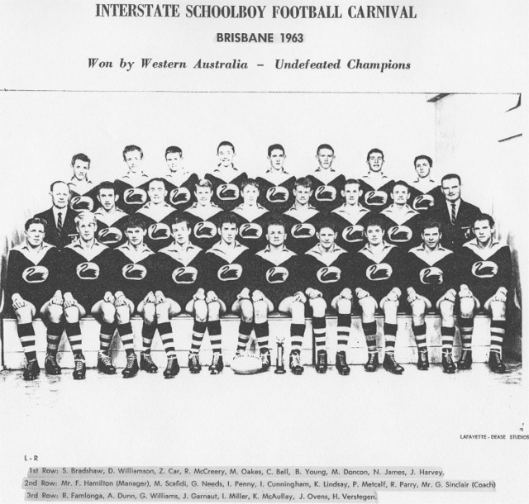

Back to teams

