AFL 15s Boys Results 1972
Competition Dates:
Venue: | Melbourne, Vic
Overall Result:

Officials
Position | Name | School
Coach | Geoff Hayes | Melville SHS
Manager | Jack McMahon**

Players
Jersey Number | First Name | Surname | School
1 | Kim | Farleigh
2 | Jamie | Lockyer | Melville SHS
3 | Angelo | Mitsopoulos | Kent St SHS
4 | Geoff | Bayliss
5 | Ken | Buck | John Forrest SHS
6 | Michael | Clarke | South Fremantle SHS
7 | Graham | Goldie
8 | Peter | LeCras
9 | Leigh | Sprylan
10 | Rick | Wake
11 | Dennis | Andrijich (VC) | Governor Stirling SHS
12 | Rod | Beck **
14 | Michael | Dermody | Wagin HS
15 | Colin | Dowson (Capt) | Belmont SHS
16 | Larry | Dwyer | South Fremantle SHS
17 | Chris | Franklin | Applecross SHS
18 | Ritchie | Green | Harvey HS
19 | David | Irvin
20 | Grant | Pollard | Jerramungup HS
21 | Bradley | Reynolds
22 | Robert | Woodhouse
23 | Graeme | Eddy | Pinjara HS
24 | Michael | Farren | Applecross SHS
25 | Michael | Fuller | Cyril Jackson SHS
26 | Geoff | Ironmonger | Scarborough SHS

(C) Captain, (VC) Vice Captain, (MW) Medal Winner, * All-Australian

Fondest Memories
The trip to Melbourne (1972) was great value as we had a chance to see and play at some of the VFL (a very strong comp in those days) grounds. One game was played at VFL Park Waverley an almost new ground and facilities that was very well equipped with indoor practice nets and every conceivable option for football . Much talk was made of the different ground conditions between WA with its dry, firm conditions and Victorias soft grass and rain. VFL Park Waverly lived up to this distinction as you would slide a huge distance in tackles on the water soaked turf, a truly unique experience. | Michael Farren
The whole experience at 15 years of age was the best | Graeme Eddy
How fit we all were. The fierce competition to get into the squad. | Chris Franklin

Interesting Stories
On the 25th of August 1973 WA had a game against Tasmania at Floreat Oval and just to add some interest I managed to arrive at the ground without a pair of football boots. With no time to retrieve my boots before the game a swift deal was struck for a slightly used pair of size 12’s curtesy of the Victorians ruckman Reg Edwards. His game with Queensland had just finished. After a close match with Tasmania for three quarters WA ran out winners by 35 points. As one of the best on ground for WA and kicking two goals (not being renound for my goal kicking skill) a few of the Victorians insisted that this is the last time I get to borrow Victorian football boots as they must have some magical properties to have such a positive effect on my game | Michael Farren
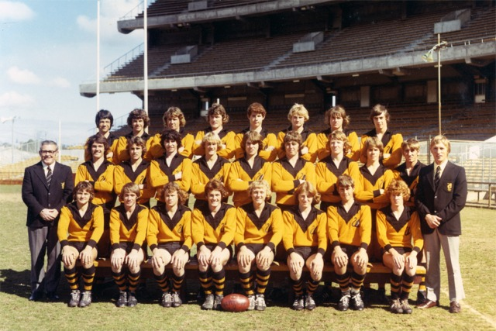

Back to teams

