AFL 15s Boys Results 1973
Competition Dates:
Venue: | Perth, WA
Overall Result:

Officials
Position | Name
Coach | Dave Heath
Manager | Bill Eddy

Players
Jersey Number | First Name | Surname | School
1 | Paul | Hyde | John Forrest SHS
2 | Ray | Stewart (VC) | South Fremantle SHS
3 | Kevin | Pratt
4 | Owen | Beckett | Cannington SHS
5 | Don | Camporeale | South Fremantle SHS
6 | Peter | Gianoli
7 | John | Pittronero
8 | Bruce | Stevenson | Como SHS
9 | Peter | Waite
10 | Graham | Pates
11 | Steve | Turner | John Forrest SHS
12 | Leigh | Brenton
14 | Ken | Judge
15 | Nick | Nicalauo
16 | Geoff | Rees | Pinjarra DHS
17 | Ken | Buck (capt) | John Forrest SHS
18 | Greg | Sherman
19 | John | Lambrecht | Hamilton HS
20 | M | Magriplis
21 | John | Florenca
22 | Wayne | Johnson
23 | Peter | Semini
24 | Stephen | Hughes
25 | Michael | Farren | Applecross SHS
26 | Dean | Mazalevskis

(C) Captain, (VC) Vice Captain, (MW) Medal Winner, * All-Australian

Interesting Stories
On the 25th of August 1973 WA had a game against Tasmania at Floreat Oval and just to add some interest I managed to arrive at the ground without a pair of football boots. With no time to retrieve my boots before the game a swift deal was struck for a slightly used pair of size 12’s curtesy of the Victorians ruckman Reg Edwards. His game with Queensland had just finished. After a close match with Tasmania for three quarters WA ran out winners by 35 points. As one of the best on ground for WA and kicking two goals (not being renowned for my goal kicking skill) a few of the Victorians insisted that this is the last time I get to borrow Victorian football boots as they must have some magical properties to have such a positive effect on my game | Michael Farren
I remember distinctly the terrific relationship I had with the coach, David Heath. David was a tremendous communicator and it was no fault of his that we blew our chances to win the championship outright on the final day, instead we had to settle with a 3 way tie. Looking forward to meeting all the guys at the reunion | Ray Stewart
Played the first game when we beat SA – from memory we came from behind. I also remember Bomber having a shot on goal to win the match against the Vics but he missed. He was a notoriously terrible kick and I never let him forget it. | John Lambrecht
Can’t remember – got wiped out in the second game and spent the carnival in hospital (ruptured spleen) but was let out temporarily to see the last match. | John Lambrecht
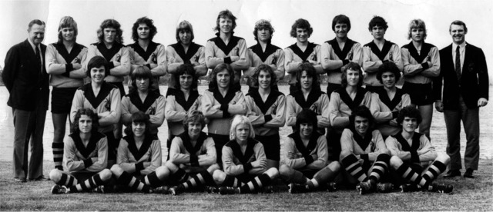
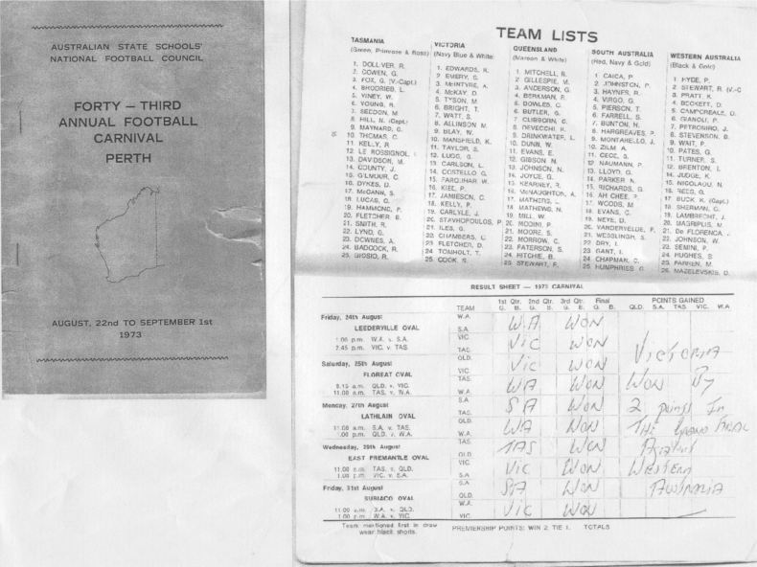

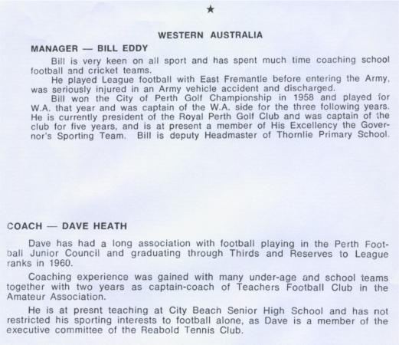

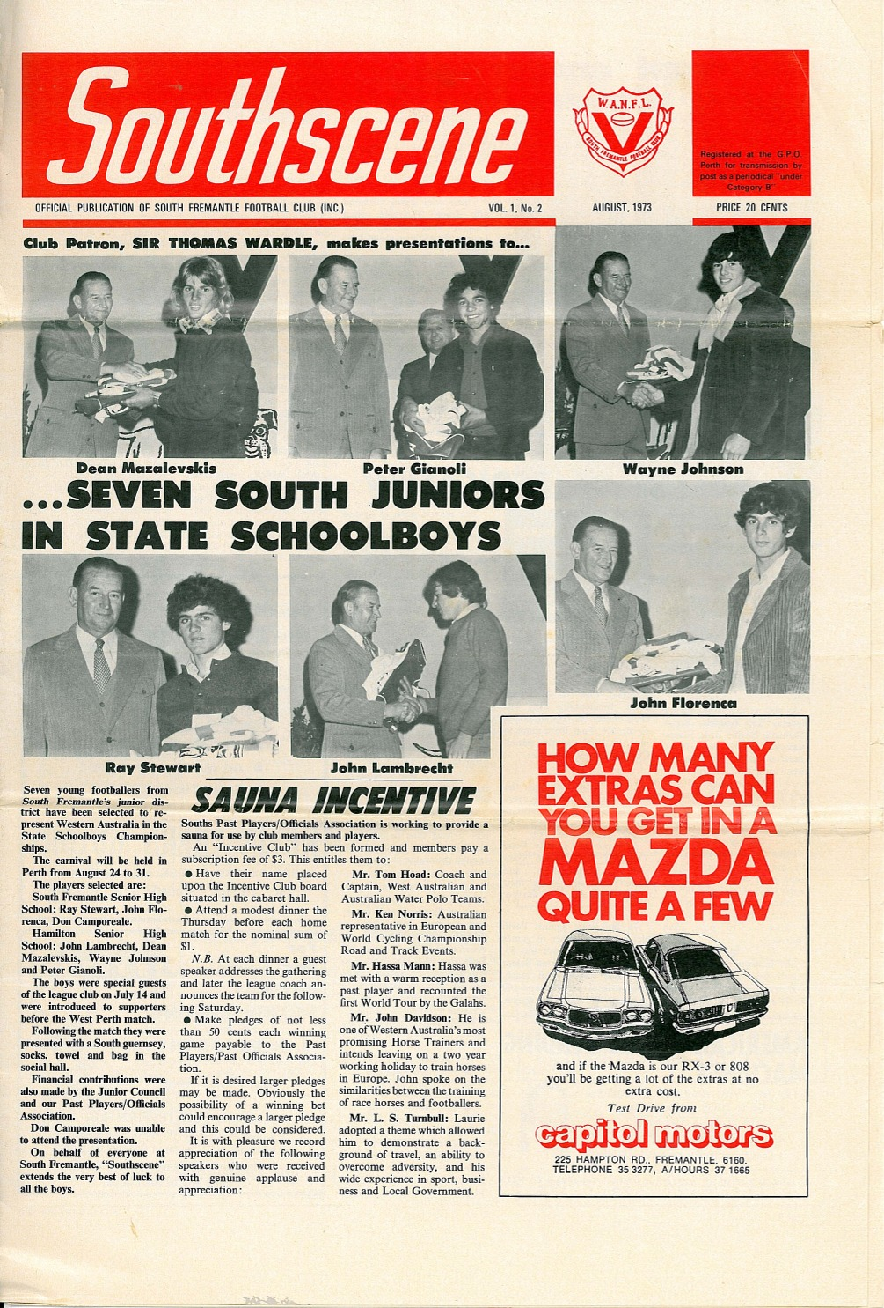

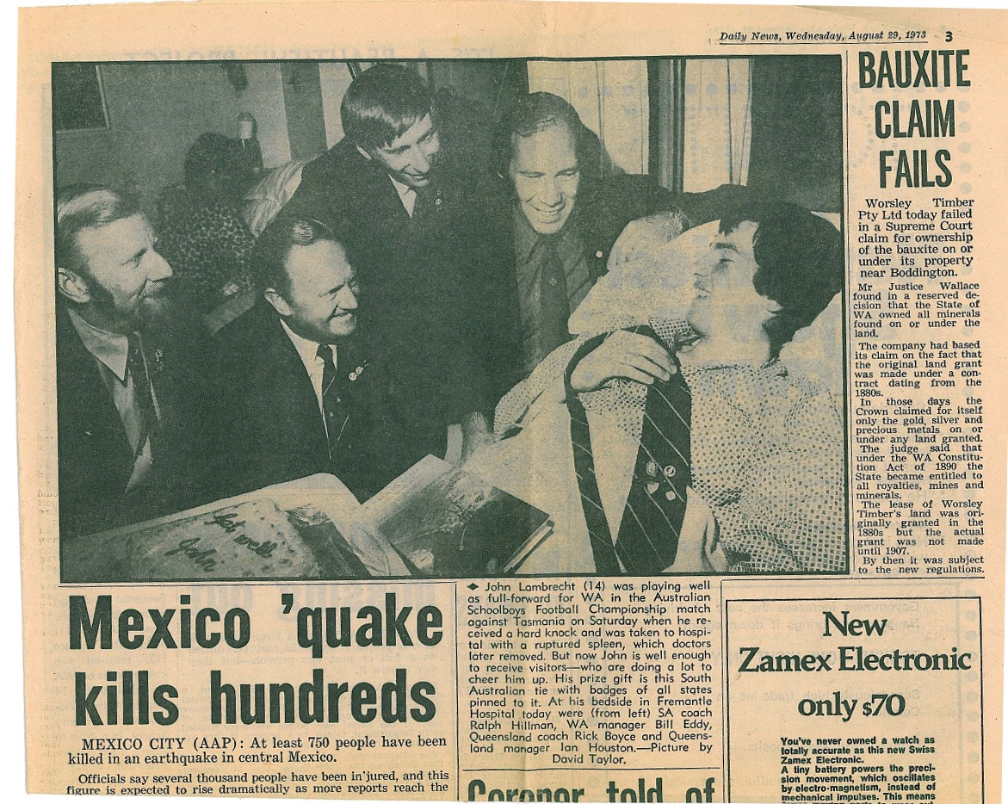

Back to teams

