AFL 15s Boys Results 1986
Competition Dates:
Venue: | Adelaide, SA
Overall Result:

Officials
Position | Name | School
Coach | Ric Evans | Padbury PS
Manager | Eddie Donnes | Armadale SHS
Trainer | Wayne Davies
WAFL Rep | Ross Davis

Players
Jersey Number | First Name | Surname | School
1 | Nathan | Spilcker | Warwick SHS
2 | Phil | Clancy | Hamilton SHS
3 | Phil | Dikolli | Cyril Jackson SHS
4 | John | Lawrence | Rossmoyne SHS
5 | David | Marriott | Ocean Reef SHS
6 | Travis | Edmonds | Guilford Grammar
7 | Craig | MacLean | Applecross SHS
8 | John | MacIntyre | Hamilton SHS
9 | Clinton | Willis | Gosnells SHS
10 | Brett | Genefini ** | Mandurah SHS
11 | Paul | Higgins | Cyril Jackson SHS
12 | Nigel | Bedford | Donnybrook DHS
14 | Glenn | Fletcher | St Patricks College
15 | Andrew | Carter | Greenwood SHS
16 | Craig | Ranson (VC) | Norseman DHS
17 | Scott | Kettlewell | John Wilcock SHS
18 | Jason | Walker (Capt) | Warwick SHS
19 | Glenn | Willgoss ** | Thornlie SHS
20 | Aaron | Zampogna | Warwick SHS
21 | Glen | Dehring | Bunbury Catholic College
22 | Ben | Stewart | Mt Lawley SHS
23 | Robert | Turner | Kelmscott SHS
24 | Anthony | Boyatsis | Trinity College
25 | Anthony | Holub | Servite College
26 | Brett | Vuleta | Lockridge SHS

(C) Captain, (VC) Vice Captain, (MW) Medal Winner, * All-Australian

Comments
I have just noticed that for the 1986 team that went to Adelaide, West Adelaide is recorded as our host team. In fact there was a last minute change (which we only found out about when we arrived in Adelaide). Central Districts became our host club and their hospitality was absolutely outstanding. | Ric Evans
My fondest memory is of playing at now AAMI stadium for our opening game and playing footy against some great teams. | Brett Vuleta

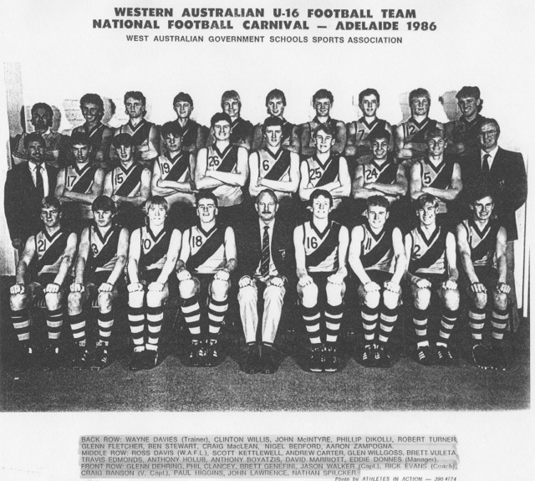
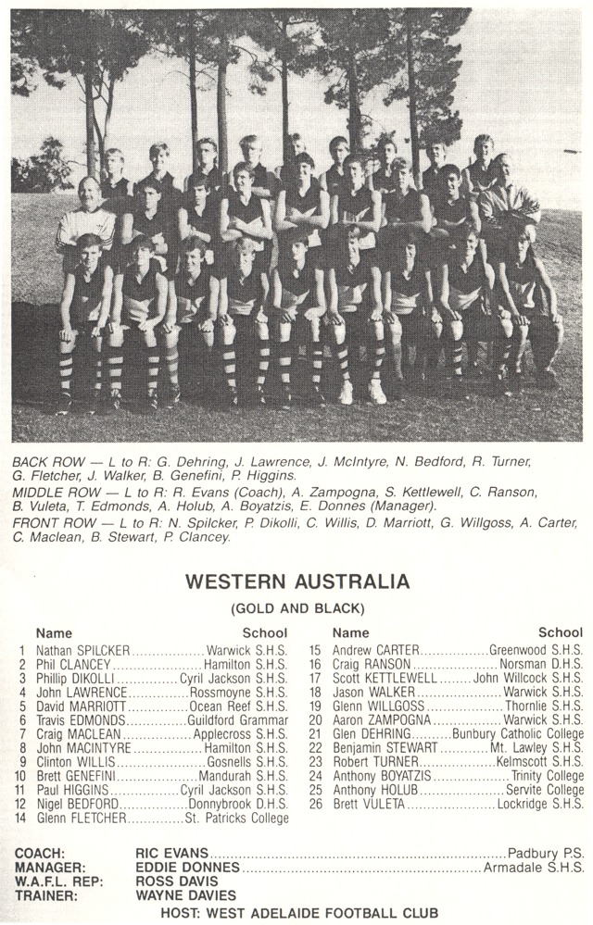

Back to teams

