AFL 15s Boys Results 1993
Competition Dates:
Venue: | Melbourne, VIC
Overall Result:

Officials
Position | Name | School
Coach | Graeme Hadley | Maddington SHS
Manager | Peter Smith | Maddington SHS

Players
Jersey Number | First Name | Surname | School
1 | Jeremy | Anderton | Lynwood SHS
2 | Matthew | Clucas | Melville SHS
3 | Andrew | de Gruchy | Narrogin SHS
4 | Bradley | Merendino | Seton College
5 | Ben | Cousins (Capt) | Wesley College
6 | Cameron | Slocombe | Sacred Heart College
7 | Matthew | DeGruchy | Servite College
8 | William | Gould | Kwinana SHS
9 | Ross | Hampson | Harvey Agricultural College
10 | Mark | Smith | Woodvale SHS
11 | Jonson | Clifton | Guilford Grammar
12 | Xavier | Teague (VC) | Hamilton SHS
13 | John | Pepe | La Salle College
14 | Clinton | Bickle | Willetton SHS
15 | Chris | Isles | Churchlands SHS
16 | Darren | Birch | Waroona DHS
17 | Clayton | Gardiner | Lake Grace DHS
18 | Ashley | Hutchinson | Donnybrook DHS
19 | Sheldon | Brady | Forrestfield SHS
20 | Steven | Galli | Newton Moore SHS
21 | Brett | Warren | Corpus Christie College
22 | Thomas | Savage | Applecross SHS
23 | Danny | Scott | Southern Cross DHS
24 | Rowan | Fulwood | Northam SHS
25 | Trent | Carroll | Warwick SHS
Captain, (VC) Vice Captain, (MW) Medal Winner, * All-Australian

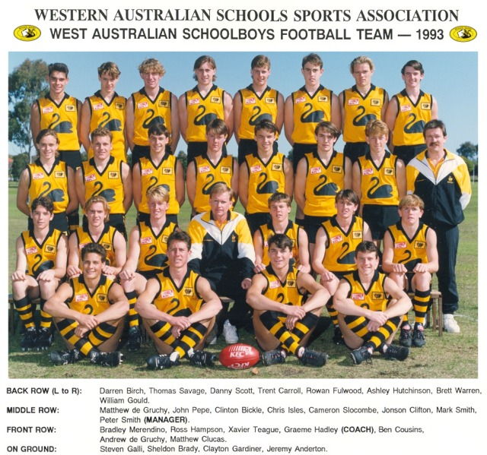
Back to teams

