


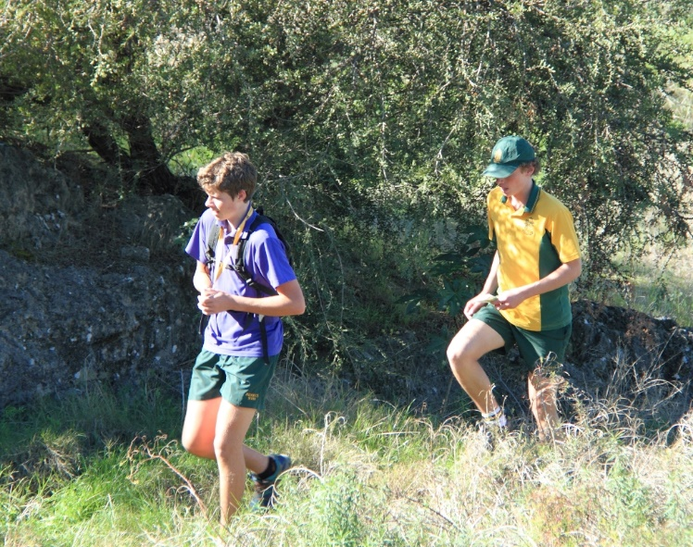
2020 WA Secondary Schools Championships
Fred Jacoby Park

Date Wednesday 17th June 2020

Location Fred Jacoby Park, Mundaring

Fred Jacoby Park is located off Mundaring Weir Road. It consists of landscaped gardens containing many trees planted from around the world. It borders on State forest to the north and west, crisscrossed by tracks. These provide a safe and interesting environment for school orienteering. This area has not been used for Schools Orienteering Championships since 2015 so will provide a new challenge for students who have participated in previous championships.

The assembly area for the Championships will be in the open parkland area. Schools are permitted to erect lightweight shelters in the cleared area to provide some protection in the event of poor weather, and to provide a base for their team. Enter via the NE end of Hampel Road which is off Mundaring Weir Road. There are toilets close to the assembly area.

Time Competitors will have start times from 10.30am at one or two minute intervals.
The Championships will conclude with an award presentation at approximately 1.00pm.

Map The map scale will be 1:10,000.
A copy of the map of Fred Jacoby Park will be sent to schools with final instructions, 1-2 weeks before the event. The map will display a mock course that can be used to help students understand the map and prepare for the event. Schools sending Outdoor Education students will also receive a copy of the OE course one week before the event. This should not be shown to non-OE students.

Your concerns
Our students haven’t done much orienteering – I’m not sure they have enough experience in map-reading and navigation. Is this event suitable for them?
Yes! While the A courses are designed to challenge students who are familiar with the sport, the B and Pairs classes are available for those with less experience and confidence. The OE class is for individuals being assessed for the Year 11/12 Outdoor Education curriculum, and is similar to the 16A course, but shorter.

Students should have an understanding of how to orient their map, e.g. using a compass, as track junctions will be important. There will be a few cross-country route choices in wooded areas. A basic understanding of contours might help students avoid unnecessary hill climbs.
My teaching schedule is pretty tight – what preparation will I need to do?
Your responsibility is to get your students safely to and from the event, and to ensure they are familiar with the competition map, and with basic orienteering procedures. This will assist your students to approach the event with confidence that they can complete their courses successfully.
What happens on the day?
Your students will each be allocated a start time and you must ensure that they come to the start grid 4 minutes before their appointed start-time. At their start signal, students navigate to all the control points in sequential order until they reach the finish. Teachers can expect most students to complete their course in 20 – 90 minutes.

FULL EVENT INSTRUCTIONS (including details of the Start procedure) AND ORIENTEERING TIPS FOR TEACHERS AND STUDENTS WILL BE FORWARDED ONE-TWO WEEKS BEFORE THE EVENT.

Competition classes (Age as at 31 December 2020)

e.g. 16th birthday is 24 October 2020 (i.e. after the event but before 31 December) – enter 16 yr & over class.

Course lengths are approximate
Girls Boys Pairs
15yr & under girls A 4.0km 15yr & under boys A 4.0km 15yr & under pairs 3.5km
15yr & under girls B 3.0km 15yr & under boys B 3.0km
16yr & over girls A 5.0km 16yr & over boys A 5.0km 16yr & over pairs 4.0km
16yr & over girls B 3.5km 16yr & over boys B 3.5km
OE - Year 11/12 girls 4.0km OE - Year 11/12 boys 4.0km

Entrants in the 15yr & under A category should have significant experience of moderate level courses at OWA events.

The OE (Outdoor Education) category can be used by schools to assess students for Outdoor Education (Years 11/12 only, no pairs). Course maps for the OE category will be sent to schools one week before the event, so that students can study their course in class before completing it on the day. Electronic timing results will be returned to schools after the event to help in teacher assessments. More experienced OE students may prefer to enter the 16yr & over A-class. They can still meet OE assessment criteria, but will not be able to view their course before the day.

Presentations Awards will be presented to the first 3 placegetters in both individual and pairs categories, and to the Champion School.

Entries Closing date for entries: 22 May, 2020 (NO LATE ENTRIES CAN BE ACCEPTED).
Use the ‘Registration” and ‘Student Names’ forms accompanying this Information Sheet.
Please scan and email the completed forms to oawa.schoolchamps@gmail.com.
Should you need to post entries, please sent the completed forms to:

Schools Orienteering Championships, PO Box 234, Subiaco, WA 6904

Entry fees Standard Entry Individual $12.00 Pairs $22.00

Orienteering WA Member Individual $8.00 Pairs $14.00

NB: The entry fee includes $2 for hire of a Sportident electronic timing chip.
SCHOOLS WILL BE CHARGED FOR ANY LOST/DAMAGED CHIPS - $25 each.

Payment It helps us if payments can be sent electronically, to:

BSB : 306-057 Account : 4180556

Ref: “SC ” (School Champs) and your school name as the ‘Reference’ eg Ref SC-Pleasant SHS

Entries sent by mail may be paid by cheque, payable to Orienteering Western Australia.

The Registration form serves as a tax invoice. No separate invoices will be issued.
There will be no refunds if students withdraw after registration, but others can be substituted in the same class up to one week before the event.

